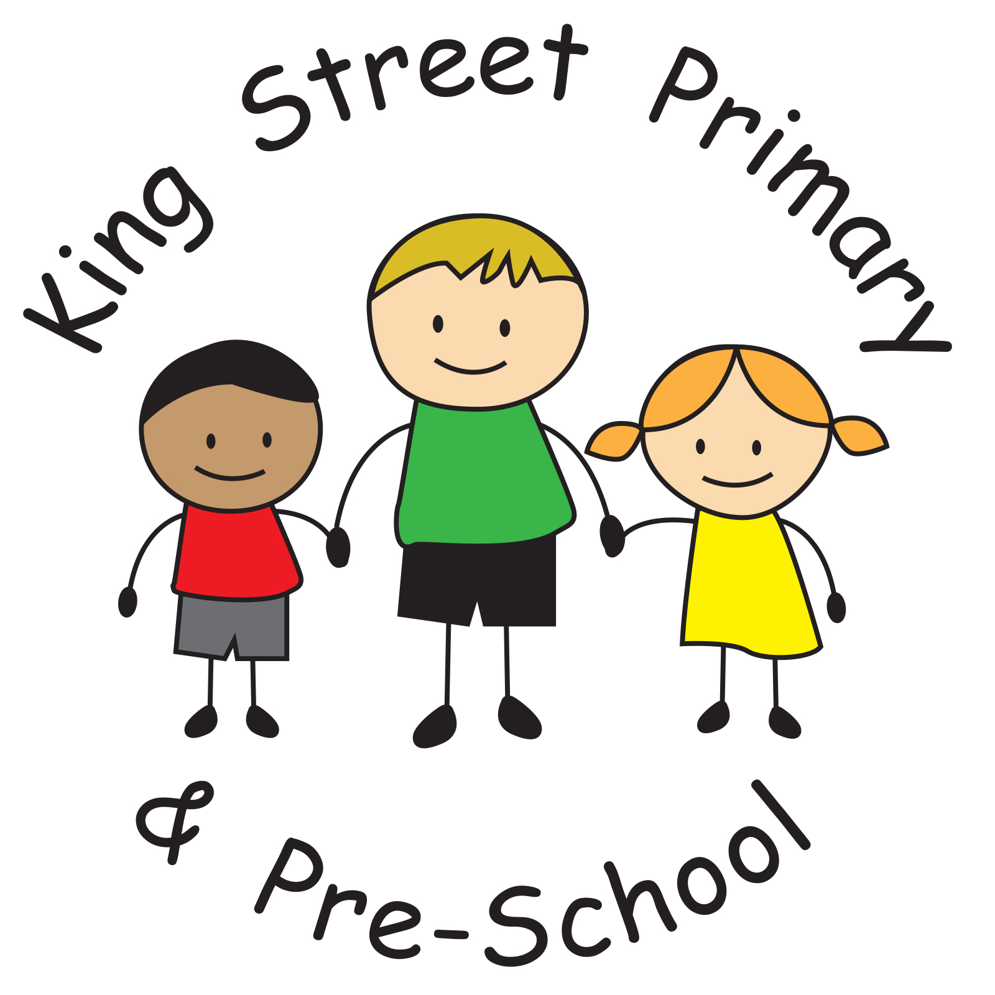
King Street Primary & Pre - School
High Grange Road
Spennymoor
County Durham
DL16 6RA

Telephone: (01388) 816078
Fax: (01388) 810661
Email: kingstreet@durhamlearning.net

Year 6 London Trip (May 2023)

Dear Parent / Guardian,

I am delighted to announce that the Year 6 residential trip to London will go ahead next year. The dates have now been confirmed - departing Wednesday 17th May and returning Friday 19th May 2023 with a cost of £270. This price will include: return travel from Durham Railway Station to London Kings Cross, accommodation at YHA Earl’s Court, tube transportation, food and entry into attractions over the three-day period.

This letter is written on the basis of information only at this stage to allow for budgeting over the next few months. Further information, regarding payments, more in-depth details of the trip and an expression of interest letter will follow in the new academic year.

Yours Faithfully,

Mr Colling

