King Street Primary & Pre - School
High Grange Road
Spennymoor
County Durham
DL166RA Telephone: (01388) 8160781
Email: kingstreet@durhamlearning.net

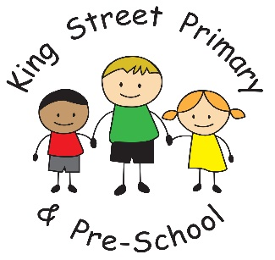

17th November 2023

Dear Parents/Carers,
It has been a fantastic atmosphere in school today. Children have shared the story of many Children In Need fundraisers, listening to stories of how the money will be spent. They have been on a Pudsey hunt, created Pudsey collages and EYFS even completed Pudsey phonics! We have not taken any monetary donations in school but the BBC website is taking donations online if you would like to donate to the cause.

Our next dress down day is next Friday (24th) and we are asking for a donation of chocolate which we use for the tombola stall at the Christmas fair.

Next week we will also be sending out requests for book a place at our Movie night on Thursday 7th December. It is important that requests are received by the deadline on the letter as we need to ensure we have time to organise the event. Please look out for this email.

Thank you to all of the parents who booked a parents’ evening appointment, it was lovely to see you all and teachers have enjoyed catching up with you about your child’s progress. I know many parents really enjoyed looking at their child’s book too.

This week our children begun singing Christmas songs, in preparation for the Christmas service at St Andrew’s church. It always seems very early to start Christmas in November but with so much to cram into this term we need to be prepared. An email will be issued to families on Monday 27th November to request tickets for our Christmas performances. Please look out for this as children love to see you there and they are always better than a West End Show!

Flu immunisations
If you missed the opportunity to have your child vaccinated against the Flu virus, there will be catch up clinics available soon or alternatively, you can contact your GP surgery.

Childhood illness
As always at this time of year, we have a number of childhood illness circulating around school. If your child has a simple cough or cold but are well in themselves, they are still welcome to come to school. If your child has had sickness bug, they must remain at home for 48 hours from the last bout of illness. This will help prevent the spread of any germs.

Upcoming Diary Dates
Friday 24th November – Dress down day- bring chocolate donation for the school fair.
Friday 1st December – Pantomime in school.
Friday 1st December- Dress down day- bring a bottle donation for the school fair.
Thursday 7th December- Movie night
Tuesday 12th December – Nativity performance
Wednesday 13th December- Nativity performance
Thursday 14th December- Christmas fair
Monday 18th December – Christmas parties across school
Tuesday 19th December – service at St Andrew’s Church
Tuesday 19th December – School closes for the festive break

As always if you have any queries or concerns please speak to, or email, the school office. Teachers can also be contacted directly by email. If you require a teacher’s email, please speak to the school office.

Yours Sincerely
J Bromley
Head Teacher

