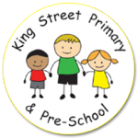Year 5 Spring Term Newsletter

Miss Lloyd, Mrs Scott and Mr Murdoch would like the opportunity to welcome everyone back after the holidays! We hope you all had a rest and are ready for what this term has in store for the children.

**Reading and Homework**

* As per last term, reading books and records will be sent out on a Monday and collected on a Friday for changing. Please take the time to read with your child daily and focus on their understanding of the text by asking questions.
* We try to avoid changing them in the week as this ensures the children have time to read and fully understand the texts. Despite not being very long, the topics are often much more sophisticated, and children require time to discuss and fully understand the theme of their book.
* Reading books must still be brought to school each day so we can listen to children read 1:1.
* Spellings will also be set on a Monday. We have ‘Home Learning’ books set up for children in which they need to complete homework. These books will need to be brought back on Fridays so new spellings can be added for the following week.
* As per last term, we will continue to focus on spelling rules and patterns.
* At times, other homework will be set on eSchools or Purple Mash so it is also important that the children remain confident using these platforms to access work. They are still able to use Purple Mash and Times Table Rockstar for times table practise.

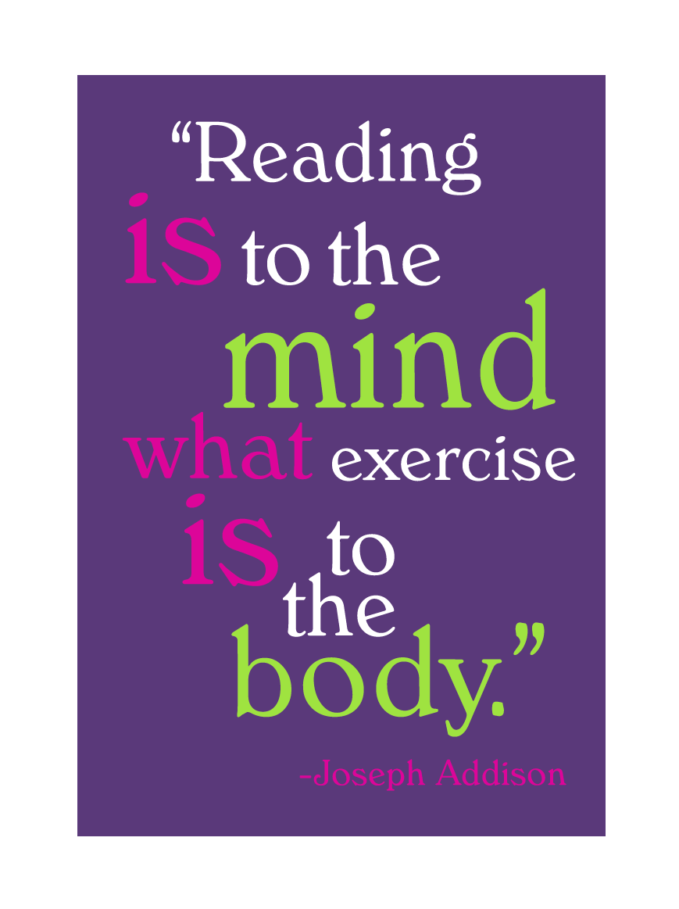

**PE**

This term our PE lessons will take place on a Wednesday and Thursday. We have swimming on a Wednesday morning and netball on a Thursday afternoon.

Pupils will need tracksuit bottoms, a sweatshirt, a plain t-shirt in their house colour and, trainers. Long hair should be tied back and earrings taken out or covered for PE. PE kits should be sent with your child on a Monday and we will send them home on a Friday.

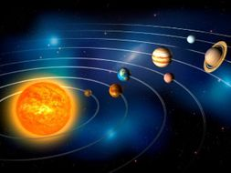Our topic this term is ‘Out of this World. As you will have guessed, we will be exploring and learning all about space and forces during this term. After our space themed ‘Science Week’ last term, I am sure many of you look forward to learning lots more about our solar system, Earth, the Moon, day and night and much more1

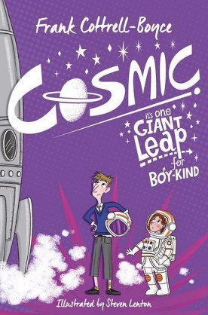Some of our reading and writing lessons will also be inspired by space. We will be reading the Frank Cottrell-Boyce story ‘Cosmic – it’s One Giant Leap for Boy-Kind’. It’s all about a boy who accidentally ends up in space!

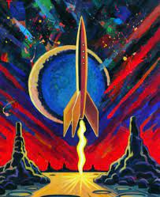In History, we will learn about the Greek states of Athens and Sparta, warfare, culture, beliefs and the legacy left behind by the Ancient Greeks. In Geography, we will be investigating the significance of latitude, longitude, Equator, Northern Hemisphere, Southern Hemisphere, the Tropics of Cancer and Capricorn, Arctic and Antarctic Circle, and time zones. As well as learning about how mountains are formed, volcanoes and earthquakes. This will link nicely with our science work about the Earth.

In Maths, we will be focusing on fractions and multiplication and division. Please ensure your child knows and regularly practises their times tables. This can be the reason many children find these concepts tricky! Children still have access to Purple Mash and Times Table Rockstars and can use these at home to practise.

In art this term, we will be exploring the work of artist Peter Thorpe. He is well known for his abstract space paintings. We will be using his work as inspiration and will be using mixed media to create our artwork.

Thank you again for your continued support. If you need to get in contact with us, please do not hesitate to email, call the school office or see me directly and I will try my best to help!

Miss Lloyd