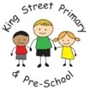EYFS Reception Curriculum Planning

Autumn Term 1 | Autumn Term 2 |  | Spring Term 1 |  |  | Spring Term 2 | Summer Term 1 | Summer Term 2
Overarching EYFS Unit themes
6th September – 21st October  (7 weeks) | 29th October – 20th December  (8 weeks) |  | January 5th – February 17th  (7 weeks) |  |  | February 27th – March 31st  (5 weeks) | 17th April – 25th May  (6 weeks) | June 5th – July 20th  (7 weeks)
This is Me!  Autumn Days | In the town where I was born  It’s Christmas! |  | Cold as Ice  All you need is love! |  |  | Here comes the sun!  Easter | Ticket to Ride  Good to Grow | Awesome Animals  Oh, I do like to be beside the seaside!
Themed Week:  Space Week | Themed Week:  World Nursery Rhyme Week  The Great King Street Bake Off |  | Themed Week:  Kindness Week |  |  | Themed Week: British Science Week | Themed Week:  International | Themed Week:  Fit for the Future  Pride Week
Key dates to mention
- Sept - Harvest  - 13th September – Roald Dahl Day  - 23rd September – First day of Autumn  - Oct - Black History Month  - 4th-10th Oct – Space Week | - 31st Oct - Halloween  - 5th Nov - Bonfire Night  - 11th Nov -Remembrance Day  - 14th November – King Charles III official birthday  - 14th November – World Nursery Rhyme Week  - 18th November – Children in Need  - 30th Nov - St. Andrew's Day  - 21st December – First day of Winter  - 25th Dec - Christmas |  | - 1st Jan - New Year  - 22nd January – Lunar/Chinese New Year (Rabbit)  - 30th Jan-6th Feb - Storytelling Week  - 6th-10th Feb – Children’s Mental Health Week  - 14th Feb – Safer Internet Day  - 14th Feb - Valentine's Day  - 21st February – Shrove Tuesday |  |  | - 1st Mar - St David's Day  - 2nd Mar - World Book Day  - 17th Mar - St Patrick's Day  - 18th Mar – Comic Relief  - 20th Mar – First day of Spring  - 19th March - Mother's Day  - 1st Apr - April Fools' Day  - 9th April - Easter | - 22nd – Earth Day  - 23rd April - St. George's Day  - 6th May – King Charles III Coronation  - 17th May – 17th June - National Smile Month (oral health) | - Pride Month  - 17th June – King Charles III Unofficial birthday  - 18th Jun - Father's Day  - 21st Jun - Summer Solstice (First day of Summer)
Communication and Language
The development of children’s spoken language underpins all seven areas of learning and development. Children’s back-and-forth interactions from an early age form the foundations for language and cognitive development. The number and quality of the conversations they have with adults and peers throughout the day in a language-rich environment is crucial. By commenting on what children are interested in or doing, and echoing back what they say with new vocabulary added, practitioners will build children's language effectively. Reading frequently to children, and engaging them actively in stories, non-fiction, rhymes and poems, and then providing them with extensive opportunities to use and embed new words in a range of contexts, will give children the opportunity to thrive. Through conversation, story-telling and role play, where children share their ideas with support and modelling from their teacher, and sensitive questioning that invites them to elaborate, children become comfortable using a rich range of vocabulary and language structures.
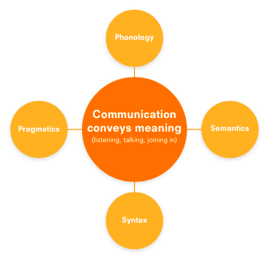 |  |  |  | Core Tasks  Family Group Time – turn-taking, speaking etc.  Read stories with repeated refrains and rhyme.  Word Aware/Greg Bottrill Vocabulary Development (Magic Hat)  Performance poetry (Poetry Basket)  Babblejab – discussion and explanation  Sticky Questions – discussion and explanation, turn-taking.  Fruit/Milk time – using questions, “would you like a pear or an apple?” Using good manners, “yes please/no thank you”  Listening games eg. Shopping lists
Autumn Term 1 | Autumn Term 2 |  | Spring Term 1 |  |  | Spring Term 2 | Summer Term 1 | Summer Term 2
- To understand how to listen carefully and why listening is important.  - To engage in story times.  - To listen carefully to rhymes and songs, paying attention to how they sound.  - To engage in non-fiction books. | - To listen to and talk about stories to build familiarity and understanding.  - To develop social phrases.  - To learn new vocabulary.  - To learn rhymes, poems and songs |  | - To use new vocabulary throughout the day.  - To ask questions to find out more and to check they understand what has been said to them.  - Describe events in some detail.  - To listen to and talk about selected non-fiction to develop and deepen familiarity with new knowledge and vocabulary. |  |  | - To articulate their ideas and thoughts in well-formed sentences.  - To connect one idea or action to another using a range of connectives.  - To use talk to help work out problems and organise thinking and activities.  - To explain how things work and why things might happen.  - To retell a story once they have developed a deep familiarity with the text, some exact repetition and some in their own words.  - To use new vocabulary in different contexts. | - To listen attentively and respond to what they hear with relevant questions, comments and actions when being read to and in whole class discussions and small group interactions.  - To make comments about what they have heard and ask questions to clarify their understanding.  - To participate in small group, class and one-to-one discussions, offering their own ideas, using recently introduced vocabulary. | - To hold conversation when engaged in back-and-forth exchanges with their teacher and peers.  - To offer explanations for why things might happen, making use of recently introduced vocabulary from stories, non-fiction, rhymes and poems when appropriate.  - To express their ideas and feelings about their experiences using full sentences, including use of past, present and future tenses and making use of conjunctions with modelling and support from their teacher.
Personal, Social and Emotional Development – Self-Regulation, managing self, building relationships
Children’s personal, social and emotional development (PSED) is crucial for children to lead healthy and happy lives, and is fundamental to their cognitive development. Underpinning their personal development are the important attachments that shape their social world. Strong, warm and supportive relationships with adults enable children to learn how to understand their own feelings and those of others. Children should be supported to manage emotions, develop a positive sense of self, set themselves simple goals, have confidence in their own abilities, to persist and wait for what they want and direct attention as necessary. Through adult modelling and guidance, they will learn how to look after their bodies, including healthy eating, and manage personal needs independently. Through supported interaction with other children, they learn how to make good friendships, co-operate and resolve conflicts peaceably. These attributes will provide a secure platform from which children can achieve at school and in later life.
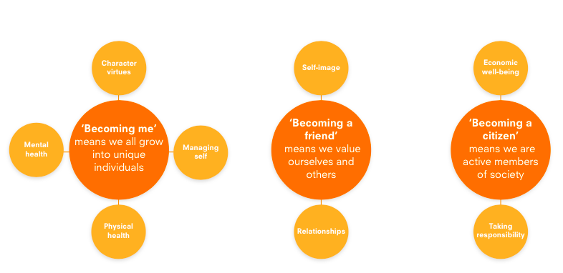
Autumn Term 1 | Autumn Term 2 |  | Spring Term 1 |  |  | Spring Term 2 | Summer Term 1 | Summer Term 2
Respectful Relationships | Caring Friendships |  | Coping Skills |  |  | Support  (people who help us) | Self-Confidence | Achievement and success
- Understanding how we belong to the school family  - Knowing ways in which we can understand how others are feeling and why this is important  - Knowing why it is important to have fun and laugh together  - Understanding why it can be good to play with people that we don’t usually play with  - Understanding how others feel when we say thank you, give them a present. Also, how we feel when we do that  - Assessment: Explaining what we have done at home to have an even better relationships with our family | - Understanding what is and isn’t friendly behaviour  - Thinking about how well we know different people and how we might react if we don’t know people that well  - Thinking about when we win and lose games – in the playground and online  - Understanding what to do if we see something that doesn’t look right on our electronic device  - Understanding that all families are similar in some ways and different in others.  - That families are important for children growing up because they can give love, stability and security.  - Thinking about how we chose our friends and how we grow our friendship circle. |  | - Identifying great and not so great feelings and who we would go to for help with our feelings  - Understanding that, by doing something different with our bodies, we can improve how we feel  - Understanding that, by changing what we say and how we say it, we can cope better when we can’t do something  - Reflecting on places that make us worry and what we can do to cope the next time that we’re there e.g. when crossing the road  - Making a collage of happy things and practising visualising this if we don’t feel calm or relaxed  - Assessment: Thinking of coping skills we have used to move nearer to achieving a personal goal |  |  | - Thinking about the help and support we need and why we need it  - Practising listening and being heard  - Understanding why it is important to listen carefully to others and the things that might distract us  - Thinking about people who support us at home and in the community  - Understanding that we all matter and make a difference  - Assessment: Explaining what we have done to improve our listening at home | - Recognising what confidence looks like- facial expressions  - Understanding how we can become more confident – through trying  - Know what we can do when we want to give up- keep trying  - Know what we can do when things get tricky- ask others, use technology, look around the room  - Recognising confidence in others – facial expressions, body language  - Assessment: Explaining how personal confidence has grown at home and at school | - Reflecting on previous achievements and things that we can’t yet do  - Understanding that some goals can be achieved quickly/ when we are young and others take longer  - Working as a team to achieve a class goal  - Working as a group to achieve a goal – turn taking, helping each other  - Talking through personal goals with older mentors/acting on advice  - Assessment: Reflecting on whether or not we have achieved our home goal
Physical Development – Gross Motor and Fine Motor Skills
Physical activity is vital in children’s all-round development, enabling them to pursue happy, healthy and active lives. Gross and fine motor experiences develop incrementally throughout early childhood, starting with sensory explorations and the development of a child’s strength, co-ordination and positional awareness through tummy time, crawling and play movement with both objects and adults. By creating games and providing opportunities for play both indoors and outdoors, adults can support children to develop their core strength, stability, balance, spatial awareness, co-ordination and agility. Gross motor skills provide the foundation for developing healthy bodies and social and emotional well-being. Fine motor control and precision helps with hand-eye co-ordination, which is later linked to early literacy. Repeated and varied opportunities to explore and play with small world activities, puzzles, arts and crafts and the practice of using small tools, with feedback and support from adults, allow children to develop proficiency, control and confidence.
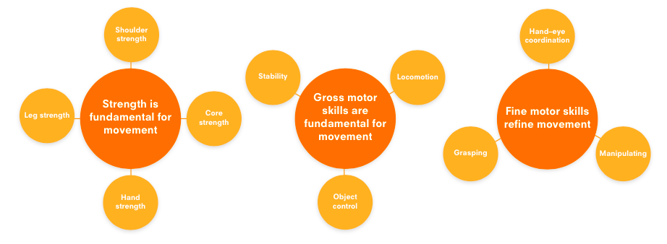
Core Tasks
Ready To Learn – 6-week programme designed to build core strength, shoulder strength and midline crossing.
Dough Disco
Squiggle me into a writer
Drawing Club – mark-making skills, early writing skills, early number formation skills.
Colouring Club – colouring activities
Cutting Club – cutting skills
Fine-Motor Club – fine motor activities
Get Sett Go! PE programme from Spring Term.
Pen Disco from Spring Term
Autumn Term 1 | Autumn Term 2 |  | Spring Term 1 |  |  | Spring Term 2 | Summer Term 1 | Summer Term 2
To negotiate space and obstacles safely, with consideration for themselves and others. | To revise and refine the fundamental movements they have already acquired: rolling, crawling, walking, jumping, running, hopping, skipping and climbing. |  | To confidently and safely use a range of large and small apparatus indoors and outside, alone and in a group. |  |  | To develop confidence, competence, precision and accuracy when engaging in activities that involve catching and throwing a ball.  To further develop and refine a range of ball skills including: throwing, catching, kicking, passing, batting and aiming. | To move energetically such as running, jumping, dancing, hopping, skipping and climbing, negotiating space and obstacles. | To develop overall body strength, balance, co-ordination and agility in both indoors and outdoors.  To demonstrate strength, balance and co-ordination when playing.
- To know and talk about the different factors that support overall health and wellbeing: regular physical activity, healthy eating, toothbrushing, sensible amounts of screen time, having a good sleep routine and being a safe pedestrian.  - To further develop the skills they need to manage the school day successfully: lining up, mealtimes, personal hygiene.  - Further develop and refine a range of ball skills including: throwing, catching, kicking, passing, batting and aiming. | - Revise and refine the fundamental movements they have already acquired: rolling, crawling, walking, jumping, running, hopping, skipping and climbing.  - Develop their overall body strength, co-ordination, balance, and agility needed to engage with future physical education sessions and other physical disciplines including dance, gymnastics, sport and swimming.  - To develop their fine motor skills so that they can use a range of tools competently, safely and confidently. E.g. pencils, paintbrushes, knives, forks and spoons. |  | - To use their core strength to achieve a good posture when sitting at a table or sitting on the floor.  - To confidently and safely use a range of large and small apparatus indoors and outside, alone and in a group.  - To develop the foundations of a handwriting style which is fast, accurate and efficient. |  |  | - To progress towards a more fluent style of moving with developing control and grace.  - To combine different movements with ease and fluency.  - To develop overall body strength, balance, co-ordination and agility.  - To develop confidence, competence, precision and accuracy when engaging in activities that involve a ball. | - To negotiate space and obstacles safely, with consideration for themselves and others.  - To move energetically such as running, jumping, dancing, hopping, skipping and climbing.  - To use a range of small tools including scissors, paintbrushes and cutlery. | - To demonstrate strength, balance and co-ordination when playing.  - To hold a pencil effectively in preparation for fluent writing – using the tripod grip in almost all cases.
Literacy
It is crucial for children to develop a life-long love of reading. Reading consists of two dimensions: language comprehension and word reading. Language comprehension (necessary for both reading and writing) starts from birth. It only develops when adults talk with children about the world around them and the books (stories and non-fiction) they read with them, and enjoy rhymes, poems and songs together. Skilled word reading, taught later, involves both the speedy working out of the pronunciation of unfamiliar printed words (decoding) and the speedy recognition of familiar printed words. Writing involves transcription (spelling and handwriting) and composition (articulating ideas and structuring them in speech, before writing).
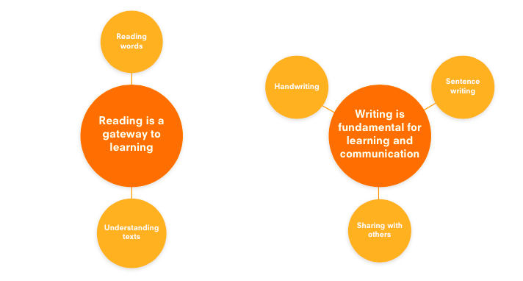 |  |  |  | Core Tasks  Daily reading session  Daily phonics session – Bug Club Phonics  One to one Reading  Small Family Group book sharing  Nursery rhymes  Poetry Basket  Book Worms Book Club - Reading for Pleasure books taken home to share with an adult alongside reading book linked to phonic ability.
Autumn Term 1 | Autumn Term 2 |  | Spring Term 1 |  |  | Spring Term 2 | Summer Term 1 | Summer Term 2
- To read individual letters by saying the sounds for them.  - To read some letter groups that each represent one sound and say sounds for them. | - To begin to blend sounds into words so they can read short words made up of known letter-sound correspondences. |  | - To read a few common exception words matched with Bug Club scheme.  - To begin to spell words by identifying the sounds then writing the sound with letter/s |  |  | - To read simple sentences made up of words with known letter/sound correspondence, and where necessary, a few exception words.  - To begin to write a short sentence with words with known letter/sound correspondences using a full stop and an awareness of a capital letter.  - To begin to re-read own sentence to check it makes sense. | - To demonstrate an understanding of what has been read to them by retelling stories and narratives using their own words and recently introduced vocabulary.  - To read words consistent with their phonic knowledge by sound blending.  To write recognisable letters, most of which are correctly formed. | - To anticipate (where appropriate) key events in stories.  - To use and understand recently introduced vocabulary during discussions about stories, non-fiction, rhymes, poems and during role-play.  - Say a sound for each letter of the alphabet and at least 10 digraphs.  - Read aloud simple sentences and books that are consistent with their phonic knowledge, including some common exception words.  - Spell sounds by identifying sounds in them and representing the sounds with letter/s.  - To write simple phrases and sentences that can be read by others.
Word-Reading - daily phonics sessions
Phonological Awareness - games for consolidation  Phase 2  Set 1: s, a, t, p  Set 2: i, n, m, d  Set 3: g, o, c, k | Phase 2  Set 4: ck, e, u, r  Set 5: h, b, f, ff, l, ll, ss |  | Phase 2 sets 3, 4, 5 recap for some children  Phase 3  Set 6: j, v, w, x  Set 7: y, z, zz, qu Consonant digraphs: ch, sh, th, ng |  |  | Phase 3  Vowel digraphs: ai, ee, igh, oa, oo, ar, or, ur, ow, oi, ear, air, ure, er | Phase 4 – Adjacent consonants (cvcc) (ccvc) | Phase 4 – Adjacent consonants (ccvcc/cccvc/cccvcc)
Tricky Words | - to  - the  - no  - go  - into  - I |  | - he  - she  - we  - me  - be  - was  - you  - they  - all  - are  - my  - her |  |  | - he  - she  - we  - me  - be  - was  - you  - they  - all  - are  - my  - her | - said  - have  - like  - so  - do  - some  - come | - were  - there  - little  - one  - when  - out  - what
Mathematics – Number, Numerical patterns
Developing a strong grounding in number is essential so that all children develop the necessary building blocks to excel mathematically. Children should be able to count confidently, develop a deep understanding of the numbers to 10, the relationships between them and the patterns within those numbers. By providing frequent and varied opportunities to build and apply this understanding - such as using manipulatives, including small pebbles and tens frames for organising counting - children will develop a secure base of knowledge and vocabulary from which mastery of mathematics is built. In addition, it is important that the curriculum includes rich opportunities for children to develop their spatial reasoning skills across all areas of mathematics including shape, space and measures. It is important that children develop positive attitudes and interests in mathematics, look for patterns and relationships, spot connections, ‘have a go’, talk to adults and peers about what they notice and not be afraid to make mistakes.
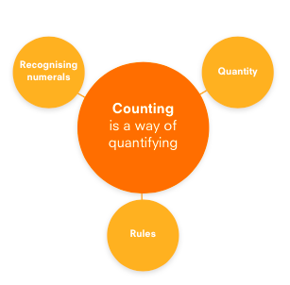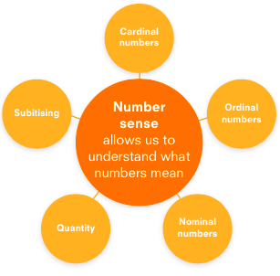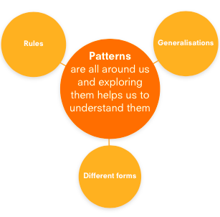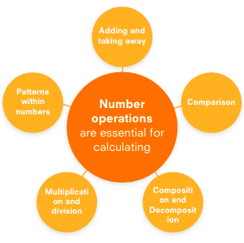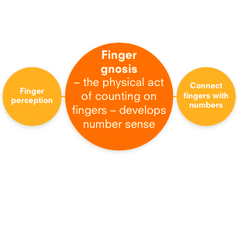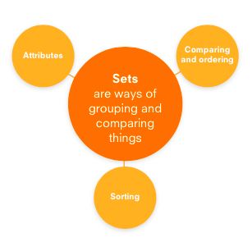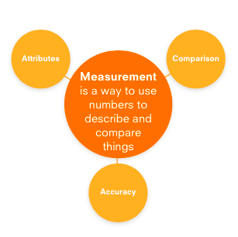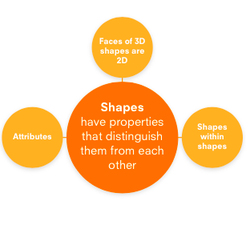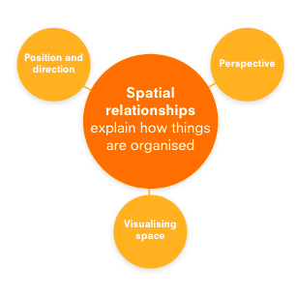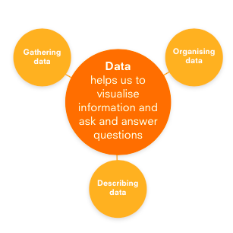

Autumn Term 1 | Autumn Term 2 |  | Spring Term 1 |  |  | Spring Term 2 | Summer Term 1 | Summer Term 2
White Rose:  Getting to know you  Just like me | It’s me 1 2 3!  Light and Dark |  | Alive in 5!  Growing 6, 7, 8 |  |  | Building 9 and 10  Consolidation | On the Move  Superhero to 20 and Beyond | First then Now  Find my Pattern
Autumn Term Progression: 1-5, sorting into groups, comparing quantities of identical objects, comparing quantities of non-identical objects, one more, one less, my day. |  |  | Spring Term Progression: Number bonds to 5, counting to 6, 7 and 8 then 9 and 10, comparing groups up to 10, comparing two groups to find the whole, number bonds to 10 – 10 frame, number bonds to 10 – part-whole model, spatial awareness, 3-D shape, 2-D shape. |  |  |  | Summer Term Progression:  making simple patterns, exploring more complex patterns, adding by counting on, taking away by counting back, counting to 20, doubling, halving and sharing, odds and evens, length, height and distance, weight, capacity.
Understanding the World – People, Culture and Communities, The World, Technology
Understanding the world involves guiding children to make sense of their physical world and their community. The frequency and range of children’s personal experiences increases their knowledge and sense of the world around them – from visiting parks, libraries and museums to meeting important members of society such as police officers, nurses and firefighters. In addition, listening to a broad selection of stories, non-fiction, rhymes and poems will foster their understanding of our culturally, socially, technologically and ecologically diverse world. As well as building important knowledge, this extends their familiarity with words that support understanding across domains. Enriching and widening children’s vocabulary will support later reading comprehension.
Autumn Term 1 | Autumn Term 2 |  | Spring Term 1 |  |  | Spring Term 2 | Summer Term 1 | Summer Term 2
- To talk about members of their immediate family and community.  - To name and describe people familiar to them. | - To comment on images of familiar situations in the past.  - To compare and contrast characters from stories, including figures from the past.  - To draw information from a simple map.  - To explore the natural world around them.  - To describe what they see, hear and feel whilst outside. |  | - To recognise that people have different beliefs and celebrate special times in different ways.  - To recognise some similarities and differences between life in this country and life in other countries. |  |  | - To understand that some places are special to members of their community.  - To recognise that some environments are different to the one in which they live.  - To understand the effects of the changing seasons on the natural world around them. | - To describe their immediate environment using knowledge from observation, discussion, stories, non-fiction texts and maps.  - To explore the natural world around them, making observations and drawing pictures of animals and plants.  - To know some of the similarities and differences between the natural world around them and contrasting environments, drawing on their experiences and what has been read in class.  - To understand some important processes and changes in the natural world around them, including the seasons and changing states of matter. | - To talk about the lives of people around them and their roles in society.  - To know some similarities and differences between things in the past and now, drawing on their experiences and what has been read in class.  - To understand the past through settings, characters and events encountered in books read in class and storytelling.  - To know some similarities and differences between different religious and cultural communities in this country, drawing upon their experiences and what has been read in class.  - To explain some similarities and differences between life in this country and life in other countries, drawing on knowledge from stories, non-fiction texts and (when appropriate) maps.
Science
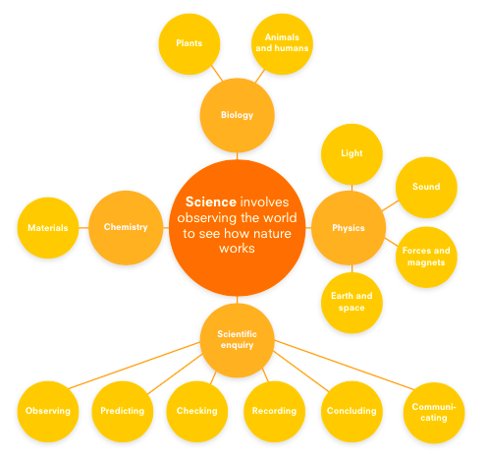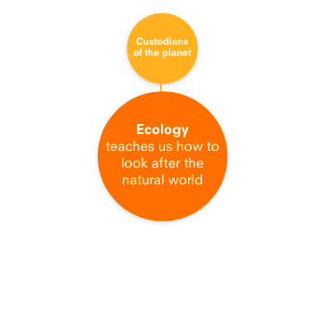
Seasonal changes – to be taught across the year (Welly Wednesday etc)
Autumn Term 1 | Autumn Term 2 |  | Spring Term 1 |  |  | Spring Term 2 | Summer Term 1 | Summer Term 2
Humans – What are the parts of my body called?  How do babies change as they grow? | Earth and Space – what is it like in space?  Light – How are shadows made? |  | Sound – How do sounds change?  Materials – What is Ice? |  |  | Animals, excluding Humans – What are animal babies called? | Living things and their habitats – Which insects might I find in my garden? | Forces and magnets – How do forces help things to move?  (making a car go faster, making a boat sink)
History – Past and Present
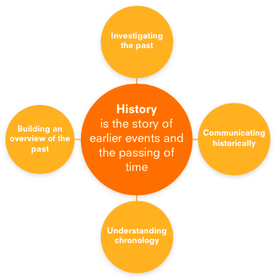
Autumn |  |  | Spring |  |  |  | Summer
All about me - How have I changed since I was a baby? |  |  | All about my school - How have things changed in our school for children attending King Street Primary School since it was built? |  |  |  | Who lives in the castle?
Investigate and interpret the past
- With some support, observe or handle evidence to ask questions and find answers to questions about their past.  - Begin to ask questions such as: What can you do now that you couldn’t do when you were a baby? What sort of toys did you play with when you were a baby? What were your parents’ favourite toys when they were little?  - Begin to use artefacts, pictures and stories to find out about the past. |  |  | - With some support, observe or handle evidence to ask questions and find answers to questions about the past.  - Begin to ask questions such as: What was it like for people? What happened? How long ago?  - Begin to use artefacts, pictures and stories to find out about the past. |  |  |  | - With some support, observe or handle evidence to ask questions and find answers to questions about the past.  - Begin to ask questions such as: What was it like for people? What happened? How long ago?  - Begin to use artefacts, pictures and stories to find out about the past.
Build an overview of world history
- Begin to describe historical events.  - Begin to describe significant people from the past. |  |  | - Begin to describe historical events.  - Begin to describe significant people from the past. |  |  |  | - Begin to describe historical events.  - Begin to describe significant people from the past.
Understand Chronology
- Begin to place events and artefacts in order on a timeline.  - Begin to label simple timelines and objects with words or phrases such as: then, now, old and new.  - Recount changes that have occurred in their own life. |  |  | - Begin to place events and artefacts in order on a timeline.  - Begin to label simple timelines and objects with words or phrases such as: then, now, old and new.  - Begin to recount changes that have occurred in their own lives. |  |  |  | - Begin to place events and artefacts in order on a timeline.  - Begin to label simple timelines and objects with words or phrases such as: then, now, past, present, old and new.  - Recount changes that have occurred in their own lives.  - With support, use dates where appropriate.
Communicate Historically - Key Vocabulary
- Begin to use words and phrases such as: a long time ago, when I was a baby, when I was in Nursery, years, yesterday, last night, this morning/afternoon and last week to describe the passing of time.  - With support, show an understanding of the concept of nation and a nation’s history – Bonfire Night, Remembrance Day etc.  - With support, show an understanding of concepts such as civilisation, monarchy, parliament, democracy, and war and peace. |  |  | - To use words and phrases such as: a long time ago, when I was a baby, when I was in Nursery, years, yesterday, today, tomorrow, last night, this morning/afternoon and last week to describe the passing of time.  - With support, show an understanding of the concept of nation and a nation’s history. |  |  |  | - To begin to use words and phrases such as: a long time ago, recently, when my parents/carers/grandparents were children, years, decades and centuries to describe the passing of time.  - With support, show an understanding of the concept of nation and a nation’s history.  - With support, show an understanding of concepts such as civilisation, monarchy, parliament, democracy, and war and peace.
Geography
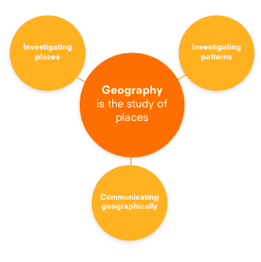
Autumn |  |  | Spring |  |  |  | Summer
My home – where do I live and what is it like? |  |  | My School - where do I live and what is it like? Which places do I visit in Spennymoor and why?  Contrasting Locality/Places around the world -Where in the world is it cold?  What is it like on a farm? |  |  |  | Contrasting Locality/Places around the world – what is it like at the beach?
Investigating places
- Starting with their own home and school, begin to ask and answer geographical questions (such as: What is this place like? What or who will I see in this place? What do people do in this place?).  - With support, use simple fieldwork and observational skills to study the geography of the school and the key human and physical features of its surrounding environment.  - During Welly Wednesday sessions and outside play, children investigate their immediate environment, the changes of the season, features, plants and creatures that can be found there. |  |  | - Begin to ask and answer geographical questions (such as: What is this place like? What or who will I see in this place? What do people do in this place?).  - Begin, with support, to identify the key features of a location in order to say whether it is a city, town, village, coastal or rural area.  - With support, begin to use aerial images and plan perspectives to recognise landmarks and basic physical features.  - During Welly Wednesday sessions and outside play, children investigate their immediate environment, the changes of the season, features, plants and creatures that can be found there. |  |  |  | Begin to ask and answer geographical questions (such as: What is this place like? What or who will I see in this place? What do people do in this place?).  Begin to explore world maps, atlases and globes to identify the United Kingdom and its countries and other places studied.  During Welly Wednesday sessions and outside play, children investigate their immediate environment, the changes of the season, features, plants and creatures that can be found there.
Investigating Patterns
- Identify seasonal and daily weather patterns in Spennymoor.  - Begin to identify places and conditions where specific creatures might be found. E.g. looking under logs for woodlice. |  |  | - Identify seasonal and daily weather patterns in Spennymoor and begin to be aware of the location of hot and cold areas of the world in relation to the Equator and the North and South Poles. |  |  |  | • Identify seasonal and daily weather patterns in Spennymoor and the location of hot and cold areas of the world in relation to the Equator and the North and South Poles with support.
Communicate Geographically
Begin to use basic geographical vocabulary to refer to:  • key physical features, including: beach, forest, hill, land, mountain, sea, river, rocks, soil and weather.  • key human features, including: city, town, village, factory, farm, house, office and shop.  Be aware of compass directions (north, south, east and west) and use locational language with support (e.g. near and far) to describe the location of features and routes on a map. |  |  | Begin to use basic geographical vocabulary to refer to:  • key physical features, including: beach, forest, hill, land, mountain, sea, river, rocks, soil and weather.  • key human features, including: city, town, village, factory, farm, house, office and shop. |  |  |  | - Use compass directions (north, south, east and west) and locational language (e.g. near and far) to describe the location of features and routes on a map.  - Devise a simple map; and use and construct basic symbols in a key.
Design and Technology
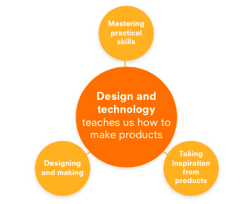
Autumn |  |  | Spring |  |  |  | Summer
Knowledge
Structures and Mechanisms Through continuous provision and planned activities, children to explore use of open-ended construction materials e.g. blocks/bricks, Mobilo, junk modelling and large construction using crates (outdoors).  Introduction of simple wheels to create vehicles.  Food To know that different ingredients can be combined to create food.  Through adult modelling and guidance, they will learn how to look after their bodies, including healthy eating. (Statutory Framework for the EYFS - Sept 2021) |  |  | Structures and Mechanisms Through continuous provision and planned activities, children to use open-ended construction materials e.g. blocks/bricks, Mobilo, junk modelling and large construction using crates (outdoors) to create a planned construction e.g. bridge for the gingerbread boy  Addition of simple wheels to create vehicles/movable objects.  Food To know that ingredients can be combined to create different flavours/textures. |  |  |  | Structures and Mechanisms Through continuous provision and planned activities, children to use plan and use open-ended construction materials e.g. blocks/bricks, Mobilo, junk modelling and large construction using crates (outdoors) to create a planned construction e.g. a water slide for the ducks.  Addition of simple wheels to create vehicles/movable objects.  Food Preparing fruit and vegetables
End Point
- Children will observe, assist and evaluate baking bread.  - To decorate Halloween biscuits.  - Children will explore the use of Sellotape, masking tape, and glue to connect materials in their models. Adults will model differing techniques where appropriate.  - Children will help to create simple snacks and items at Welly Wednesday eg. Bird feeders, cheese wraps.  - Children will create models of their choosing construction materials. |  |  | - Children will observe, assist and evaluate making pancakes.  - Children will observe and assist in baking gingerbread men.  - Children will observe and assist in making Easter Nests.  - Children will begin to use a range of ways to join materials used in their modelling.  - Children will create and cook a variety of simple snacks on the fire pit at Welly Wednesday e.g. ‘smores, simple pizza etc.  - Children will create a simple bridge structure strong enough to hold an object from open-ended construction materials. |  |  |  | - Children will design, make and evaluate their own sandwiches.  - Children will use a range of suitable ways to join materials used in their modelling.  - Children will help to create simple snacks and items at Welly Wednesday eg. Fruit skewers  - Children will create a planned structure such as a water slide for the toy ducks using open-ended construction materials.
Master Practical skills
Food  - To gain a developing understanding of simple food hygiene.  - To weigh ingredients using scales with a simple scale (or arrow to indicate the correct measurement).  - To assist in assembling and observe cooking of ingredients.  - To plan a simple design for biscuit.  Materials  - To begin to use scissors to cut snips in paper and thin carboard.  Construction  - To begin to use simple tools such as a hand drill, hammer and saw (Forest School) to make changes to materials.  - To explore open-ended classroom resources such as wooden blocks, Mobilo and junk modelling. |  |  | Food  - To continue to develop an understanding of simple food hygiene.  - To weigh ingredients using scales with a simple scale (or arrow to indicate the correct measurement).  - To use a knife to cut vegetables such as cucumber for feeding the guinea pigs and tortoise in class.  - To assemble and observe cooking of ingredients.  Materials  - To develop the use of scissors to cut straight lines in paper and cardboard and begin to cut angles and curves.  Construction  - To develop the use of simple tools such as a hand drill, hammer and saw (Forest School) to make changes to materials.  - To begin to use open-ended classroom resources such as wooden blocks, Duplo, Mobilo and junk modelling to create a planned outcome. |  |  |  | Food  - To demonstrate an understanding of simple food hygiene.  - To use a knife to spread butter and toppings onto bread.  - To use a knife to cut the sandwich in half.  - To use a knife to cut vegetables such as cucumber for feeding the guinea pigs and tortoise in class.  Materials  - To use scissors to cut straight lines, angles and curves in paper, cardboard and fabric with increasing accuracy.  Construction  - To develop the use of simple tools such as a hand drill, hammer and saw (Forest School) to combine materials.  - To confidently plan and create an object using the open-ended classroom resources such as wooden blocks, Lego, Mobilo and junk modelling.
Design, Make and Evaluate
- To explore and taste test a variety of breads.  - To taste final product and discuss likes and dislikes, talking about what would have improved the bread. *This process may need to be modelled by adult to help introduce children to new vocabulary. |  |  | - To explore possible toppings and combinations for pancakes.  - To draw a picture of their gingerbread man and then decorate gingerbread man using a combination of icing and sweets for desired effect. Reflect upon completed design.  - Use construction items in classroom to create bridges for different purposes and strong enough to hold different weights/objects including the gingerbread boy. |  |  |  | - To explore different sandwich fillings.  - To choose bread type and fillings.  - To taste-test and discuss final product.
Key Vocabulary
- Dough, knead, mix, rise, weigh, ingredients, method, combine, soft, |  |  | - Slice, sweet, spicy, |  |  |  | - Spread, toppings, combination, half, slice
Take inspiration from design throughout history
- To look at a variety of bread types from across the globe and from history. |  |  | - Discussion of known toppings that the children have tried before. Researching other toppings from the internet.  - Look at pictures of various bridge designs and discuss the materials and shapes used. |  |  |  | - Look at pictures of vehicles and discuss structures and materials.
Computing - computer science, information technology and digital literacy
Children will learn to use the functions on a CD player, use the iPad/Tablet as a camera/scan a QR code, access an app on a tablet e.g. Bug Club Phonics, playing a game on the IWB, simple coding/programming – using Doc robot/Code-a-pillar/Mind robot.

https://www.barefootcomputing.org/earlyyears
AWESOME AUTUMN  Curriculum Links:  Early Years  Concepts & Approaches:  Creating, Pattern, Logic, Algorithms, Decomposition, Collaborating  Three Autumn themed activities which see the children explore patterns in Garlands Galore, create a leaf labyrinth and make Pumpkin Soup using computational thinking skills.  Barefoot BUSY BODIES  Curriculum Links:  PSHE, English, Science  Concepts & Approaches:  Algorithms, Decomposition, Debugging, Logic, Patterns, Abstraction  Provides four activities that help children discover how bodies move and grow. Using the resources provided they explore and learn about parts of the body, growth and movement.  Simple algorithms are created and adapted to form a routine of movements.  SUPER SPACE  Curriculum Links:  Science  Concepts and Approaches:  Algorithms, Collaboration, Persevering, Creating, Pattern, Logical reasoning, Tinkering, Abstraction  Includes 3 space themed activities to develop pupils computational thinking and problem-solving skills. Include creating algorithms to direct a rocket through space and spotting patterns in pictures of aliens. |  |  | WINTER WARMERS  Curriculum Links:  Early Years  Concepts & Approaches:  Algorithms, Creating, Collaboration, Decomposition, Tinkering, Persevering  Snowmen scarves and patterns, creating igloos and bird feeders- all take centre stage in our three winter themed activities.  SPRINGTIME  Curriculum Links:  Early Years  Concepts & Approaches:  Abstraction, Tinkering, Creating, Collaborating, Algorithms, Persevering, Decomposition  Three Spring themed activities see the children make a Rabbit run, create Junk scarecrows and explore sequencing whilst planting seeds. |  |  |  | BOATS AHOY  Curriculum Links:  Science, Maths, English, D&T  Concepts & Approaches:  Algorithms, Decomposition, Creating, Tinkering, Logic, Patterns, Abstraction, Collaborating  Takes children on a journey of discovery as they investigate boats. Four activities make up this set of resources. Includes different uses of boats, floating and sinking predictions, creating a good boat through exploring designs and role play.  SUMMER FUN  Curriculum Links:  Science, Maths, English, D&T  Concepts & Approaches:  Tinkering, Persevering, Patterns, Logic, Decomposition, Debugging, Collaborating, Algorithms  Children explore their surroundings and get creative, take a journey and make a map, and discover seaside tangrams, in these three fun activities.
Online safety – www.nationalonlinesafety.com
Online Relationships This topic covers ways in which information can be put online and how devices can be used to communicate with others.  Online Reputation This topic covers ways in which people can use technology to communicate. |  |  | Copyright & Ownership This topic aims to teach young learners the importance of labelling their work.  Health, Well-being & Lifestyle This topic introduces basic rules to help keep children safe online.  Managing Online Information This topic identifies the different technologies that can be used to access the Internet. |  |  |  | Privacy & Security This topic introduces the types of personal information.  Self Image & Identity This topic covers understanding emotions and responding to scenarios that make them feel uncomfortable online.  Online Bullying This topic covers recognising negative behaviour online and its impact.
RE
Autumn Term 1 |  | Autumn Term 2 | Spring Term 1 |  | Spring Term 2 |  | Summer Term 1 |  | Summer Term 2
Let’s find out about a church – visit to St. Andrew’s Church in Spennymoor – What happens there? What will I see?  Let’s find out about Harvest in a Church.  Let’s find out about Shabbat.  Let’s find out about a Sukkot. |  | Let’s find out about the Christmas Story and Christmas celebrations in Churches.  How and why is Christmas celebrated by Christians? | Let’s find out about holy books (e.g. the Qur’an, the Torah, the Guru Granth Sahib). |  | Let’s find out about the Easter Story and Easter celebrations in Churches.  How and why is Easter celebrated by Christians? |  | Let’s find out about special buildings and worship there (e.g. mandir, church, synagogue, Buddhist Rupa).  Comparing a Christian church to a Jewish Synagogue. |  | Let’s find out about special buildings and worship there (e.g. mandir, church, synagogue, Buddhist Rupa).  Comparing a Christian church to a Hindu Mandir
Expressive arts and design – Creating with Materials, Being imaginative and expressive
The development of children’s artistic and cultural awareness supports their imagination and creativity. It is important that children have regular opportunities to engage with the arts, enabling them to explore and play with a wide range of media and materials. The quality and variety of what children see, hear and participate in is crucial for developing their understanding, self-expression, vocabulary and ability to communicate through the arts. The frequency, repetition and depth of their experiences are fundamental to their progress in interpreting and appreciating what they hear, respond to and observe.
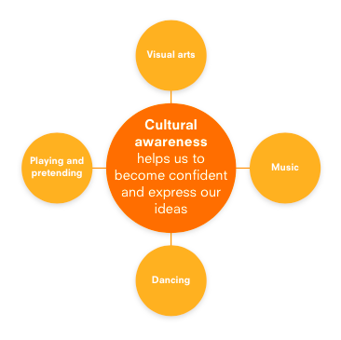
Autumn Term 1 | Autumn Term 2 |  | Spring Term 1 |  |  | Spring Term 2 | Summer Term 1 | Summer Term 2
Art
Children can describe the work of Picasso.  (with adult support)  (Collage Project) |  |  | Children can describe the work of Vincent Van Gogh (with adult support)  (Painting Project) |  |  |  | Children can describe the work of Andy Goldsworthy (with adult support)  (Natural Sculptures Project)
Develop Ideas:  - Children begin to explore a range of materials and tools.  - With support, begin to respond to ideas and starting points.  - With support, begin to explore ideas and collect visual information.  - With support, begin to explore different methods and materials as ideas develop. |  |  | - Children can begin to create artwork using suggested materials and techniques.  - With support, begin to respond to ideas and starting points.  - With support, begin to explore ideas and collect visual information.  - With support, begin to explore different methods and materials as  ideas develop. |  |  |  | - Children can create artwork using a range of materials and techniques  - Children can begin to select appropriate tools and materials for their artwork.  - With support, begin to respond to ideas and starting points.  With support, begin to explore ideas and collect visual information.  - With support, begin to explore different methods and materials as  ideas develop.
Mastering Techniques  Painting  - Explore making marks with hands and fingers and thick and thin brushes on large scale outdoors and indoors.  - Explore natural paintbrushes made from found materials.  - Begin to explore colour mixing.  Collage  - Use a combination of materials that are cut, torn and glued.  - Sort and arrange materials.  - Mix materials to create texture.  Sculpture  - Explore a variety of materials including open-ended wooden blocks, bricks, natural materials to create transient structures.  - Explore malleable materials such as dough – manipulation using hands to squeeze, twist, roll etc. and simple tools to cut, roll, stamp etc.  Drawing  - Copy lines and circles and begin to progress through the remaining pre-writing shapes.  - Create closed shapes with continuous lines and begin to use these shapes to represent objects.  - Draw with increasing complexity and detail, such as representing a face with a circle and including details.  - Use drawing to represent ideas like movement or loud noises.  Print  - Explore a range of natural and man-made materials to create a print.  Textiles  - Explore adding strips of fabric and wool to collages. |  |  | Painting  - Continue to explore making marks with thick and thin brushes on large scale outdoors and indoors, showing a greater control.  - Use natural paintbrushes made from found materials.  - Continue to explore colour mixing.  Collage  - Use a combination of materials that are cut, torn and glued.  - Sort and arrange materials.  - Mix materials to create texture.  Sculpture  - Explore a variety of materials including open-ended wooden blocks, bricks, natural materials to create transient structures with an end result in mind.  - Continue to explore malleable materials such as dough – manipulation using hands to squeeze, twist, roll etc. and simple tools to cut, roll, stamp etc with an end result in mind.  Drawing  - Confidently copy all of the Pre-Writing shapes.  - Begin to colour (own work) following the lines.  - Begin to select appropriate colours for task.  - Add more detail to drawings such as adding eyelashes and hair to pictures of faces.  - A body should now consist of a head, torso and appropriate numbers of arms and legs.  Print  - Explore a range of natural and man-made materials to create a print.  Textiles  - Explore adding strips of fabric and wool to collages. |  |  |  | Painting  - Use thick and thin brushes.  - Begin to mix primary colours to make secondary colours.  Collage  - Use a combination of materials that are cut, torn and glued.  - Sort and arrange materials.  - Mix materials to create texture.  Sculpture  - Use a combination of shapes.  - Begin to use rolled up paper, straws, paper, card and clay as materials.  - Use techniques such as rolling, cutting, moulding and carving with hands and simple tools.  Drawing  - Begin to colour (own work) more neatly following the lines.  - Choose appropriate colours for task.  - Body drawing should now consist of a head, torso, arms, legs, feet and may include fingers etc in details.  Print  - Explore a range of natural and man-made materials to create a print/pattern  Textiles  - Explore adding strips of fabric and wool to collages.
Communicate artistically – Key Vocabulary
Portrait, artist, paint, collage, squeeze, twist, roll, stamp, print, cut, mix, cut, torn, glue, stick, arrange, thick/thin brush |  |  | Smooth, rough, detail, |  |  |  | Primary/secondary colours, texture, pattern,
Take inspiration from the greats:
- Describe the work of notable artists, artisans and designers.
- Use some of the ideas of artists studied to create pieces.

Performance Poetry - Poetry Basket
Shoes  Chop-Chop  Five Little Owls  Five Little Pumpkins  A Basket of Apples | Leaves are Falling  Who Has Seen the Wind?  Mice |  | Carrot Nose  A Little House |  |  | Pancakes  Spring Wind  Stepping Stones | I Have a Little Frog  Pitter Patter  Monkey Babies | A Little Shell  I Were So Very Small
Music
Core Tasks
Hello song every morning (signed song)
Play music from www.musicforassemblies.co.uk after lunchtime each day
Funky Friday – children sing and dance to a variety of different music.
Autumn Term 1 | Autumn Term 2 |  | Spring Term 1 |  |  | Spring Term 2 | Summer Term 1 | Summer Term 2
All About Me | Light and Dark |  | Sounds All Around Me |  |  | Traditional Tales | Travelling Around | Holidays and the Seaside
In this unit children will be encouraged to find their singing voice and explore other vocal sounds. They will learn a repertoire of simple songs that they can become familiar with and have experience of putting actions to songs and moving to the pulse. | In this unit children will learn songs and explore sound making with instruments and everyday objects on the themes of night and day, space, Diwali and Christmas. They will consolidate their awareness of pulse, beat and sound patterns or rhythms and explore the concepts of dynamics and tempo. |  | In this unit the children will develop their listening skills and sound discrimination skills. They will explore everyday sounds that they hear around them. They will start to be aware that they can make sounds to add effects to stories. They will become familiar with class instruments and know their names and how to play them correctly. |  |  | In this unit children will have an opportunity to use their voices and percussion instruments to explore how sounds can be made and become aware that sounds can be changed. There will be the opportunity to listen and move to music and learn about how music changes in tempo – fast/slow and dynamics – loud/quiet. | In this unit children will learn a number of rhymes and cumulative songs to enjoy singing as a class and help to develop confidence using their voice. Through songs and music games they will be able to develop an understanding of the steady pulse. They will have the opportunity to explore instrumental, vocal and body percussion sounds. | In this unit children will use instruments and vocal sounds to create s a sound story about a Treasure Island. Children will extend their range of songs and have the opportunity to reinforce their understanding of how sounds can be made and changed.
- To learn some songs by heart.  - To sing in a group or on their own.  - To be able to tap out the rhythm of their own name.  - To keep a simple beat.  - To perform simple  - actions to a song. | - To focus and develop listening skills.  - To recognise and broadly control changes in timbre, tempo, pitch and dynamics when playing instruments and vocally.  - To perform to a beat/pulse.  - To be able to tap patterns of sounds in words.  - To respond and move appropriately to music.  - To play instruments to music, beginning to become aware of the pulse or beat.  - To explore changes in sounds and be able to create different sounds using different class instruments. |  | - To focus on sounds and develop listening skills.  - To explore sounds and how to change them.  - To explore and learn how sounds can be changed.  - To add sound effects to a story.  - To explore different sounds of instruments.  - To become familiar with a variety of percussion instruments and know how to play them with increasing control.  - To explore the sounds of instruments and know how to change them (Dynamics: loud, quiet, Tempo: fast/slow)  - To understand that sounds can be long and short.  - To begin to make patterns with sound. |  |  | - To explore changes in high/low sounds  - To match actions to music  - To explore musical instrument sounds.  - To learn some simple songs by heart and begin to sing confidently in a group.  - To explore the different sounds of instruments.  - To begin to move with a sense of rhythm.  - To enjoy singing songs from memory and build up a wide repertoire of songs. | - To join in and enjoy singing a variety of songs  - To explore sounds through music games and listening activities.  - To sing simple, familiar songs.  - To explore the different sounds of instruments.  - To listen to high and low sounds and move with the music.  - To explore ways that different types of sound can be made (timbre)  - To begin to show awareness that sounds can be represented with symbols (the beginning of understanding notation) | - To explore different sounds.  - To create representations of events using sounds and movement.  - To join in with singing songs and rhymes.  - To explore making loud/quiet sounds.  - To develop listening skills.  - To extend repertoire of action songs and rhymes.  - To be aware of changes in sounds of high and low pitched notes.
Autumn Term 1 | Autumn Term 2 |  | Spring Term 1 |  |  | Spring Term 2 | Summer Term 1 | Summer Term 2
Reception Class Visits/Cultural Capital
Library  St. Andrew’s Church – parts of a church/harvest  Dentist/Doctor/Nurse/Police Visit | Library  Post Office  Church – Christmas  Spennymoor Settlement - pantomime |  | Library  Spennymoor Clay Café - painting egg cups |  |  | Library  Church – Easter  Leisure Centre – sports/pink gym  Seven Stories  Police Visit – Jet and Ben | Library  Hall Hill Farm  Garden Centre  Church - Wedding  Shildon Railway Museum Bus ride  Firefighter visit | Library  Seaham beach for ice cream  Vet visit  Spennymoor Pink Gym
Parental Engagement
Tapestry  Meet the Teacher  Phonics workshop  Harvest Festival – St. Andrew’s Church | Tapestry  Stay and Play – parent/Teacher consultation  Christmas Nativity  Christmas Service – St. Andrew’s Church |  | Tapestry |  |  | Tapestry  Stay and Play – parent/Teacher consultation  Easter Service – St. Andrew’s Church | Tapestry | Tapestry  Sports Day  Teddy Bear’s Picnic

