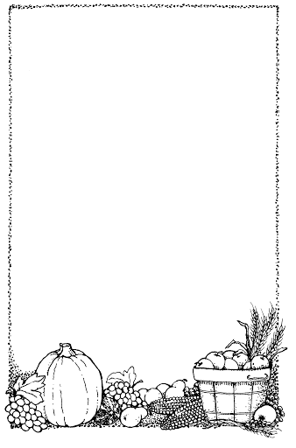
Chop Chop

Chop, Chop, Choppity Chop.

Cut off the bottom and cut off the top.

What there is left, we put in the pot.

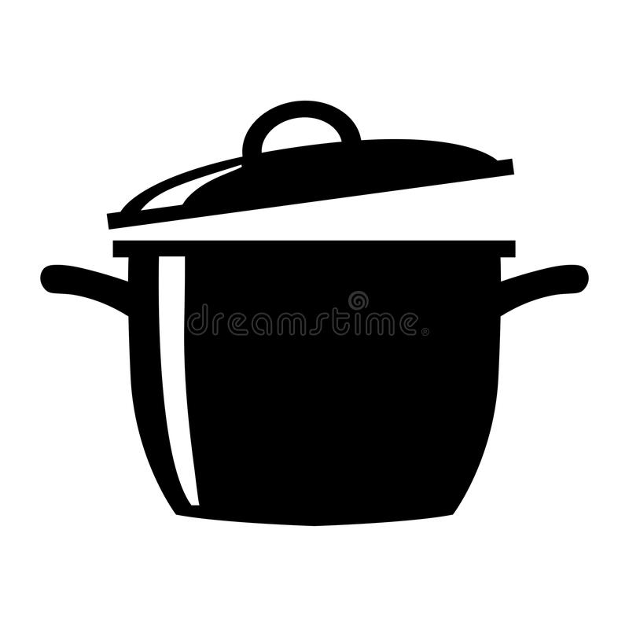
Chop, Chop, Choppity Chop.
The Poetry Basket www.helicopterstories.co.uk

