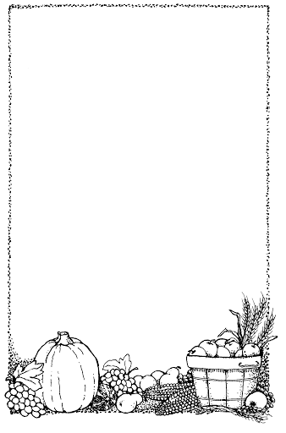
Pointy Hat

A little old lady with a tall pointed hat,

Knocked on my door with a rat-a-tat-tat.

I peered through the window to see who was there,

And off on her broomstick she flew through the air.

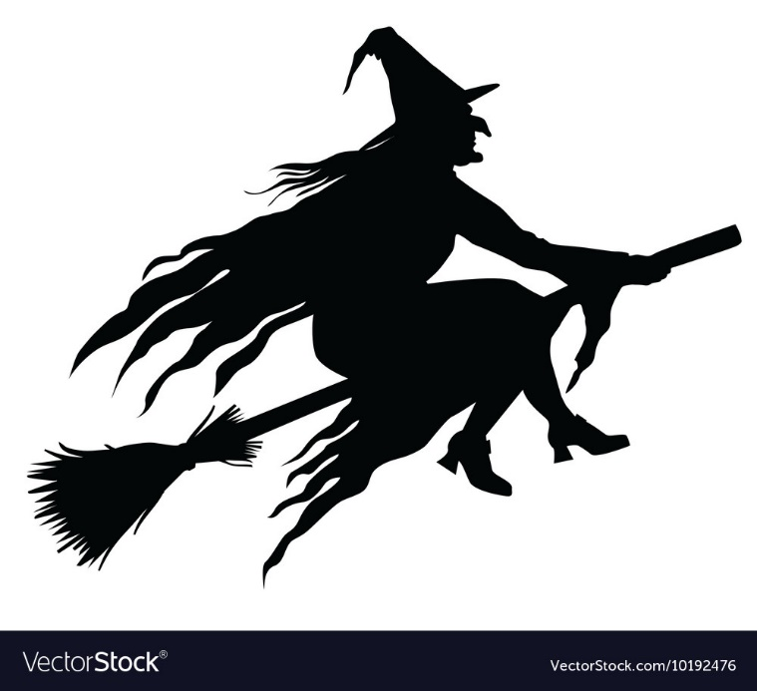

The Poetry Basket www.helicopterstories.co.uk

