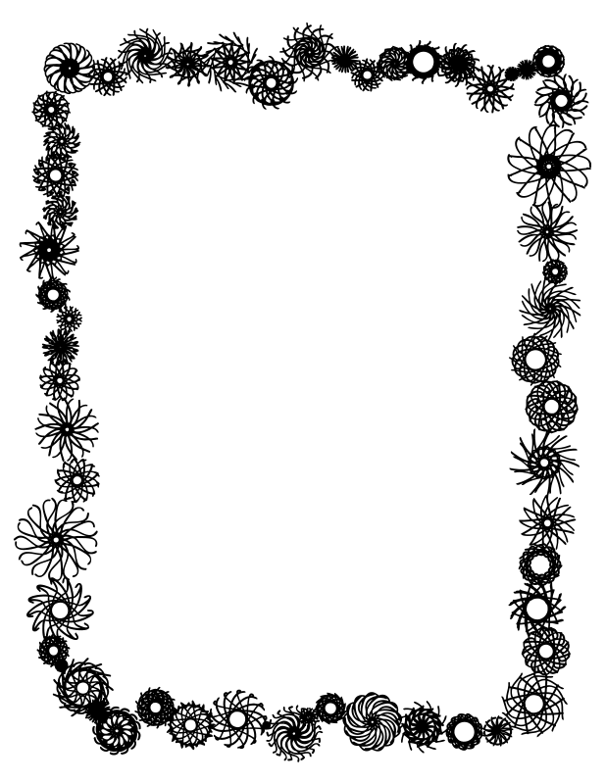

**I Can Build a Snowman**

I can build a snowman,

I can build it high.

I can build a snowman,

Up into the sky.

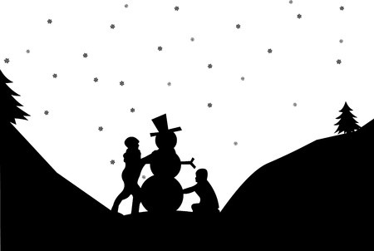

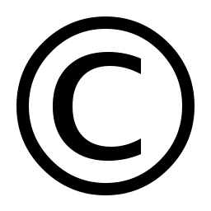

The Poetry Basket www.helicopterstories.co.uk