Year 6 Autumn Term Newsletter
Mr Colling and Mr Swift would like to take this opportunity to welcome everyone back after the summer holidays. We hope you are all well and are ready for what this year has to offer!

This year our curriculum will ensure that all children are given opportunities to develop their interests and skills, and that their learning is broad, balanced, engaging and fun! Lessons will be taught through longer-term topics, using texts to help broaden your child's vocabulary, deepen their understanding, and provide a context for their own work.

Below is some information about day-to-day school routines, expectations and our theme this term.

Daily Routines
All children will enter school via the main pedestrian gate at the Early Year’s yard, from 8.30am. Year 6 pupils will then enter the school building via the Sports Yard’s doors, as they did in Year 5. At the end of the school day, Year 6 pupils will leave via the same door at 3.15pm. If you are collecting your child, please wait in the Sports Yard. Walking home letters for this academic year, must be signed and returned, if you wish your child to leave school without being accompanied by an adult.
The register will be taken at 8.45am, however, I’d like to take this opportunity to emphasise the importance of children arriving at our earliest flexible arrival time of 8.30am, as much vital learning takes place during our SAT’s Early Bird booster arithmetic sessions.
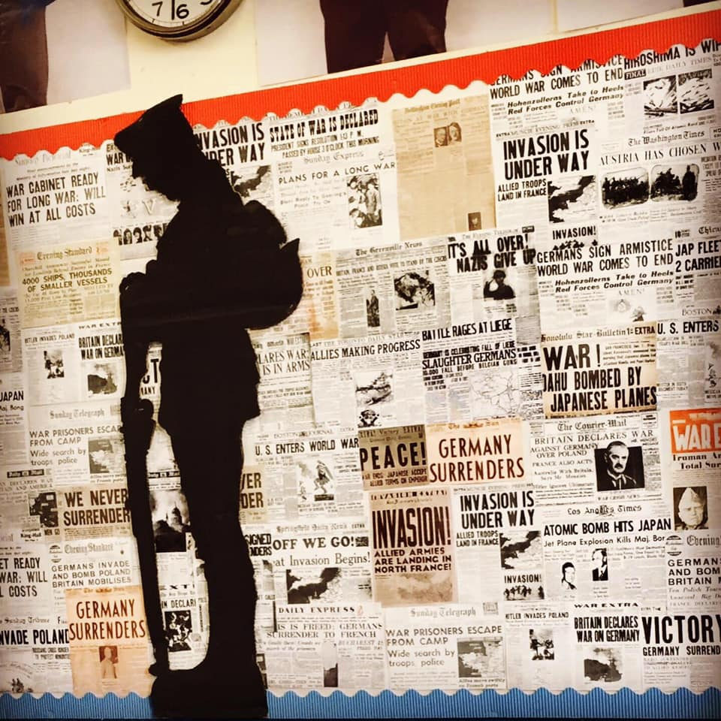
Topic-based Learning
Over the course of this term, Year 6 will be learning and asking questions all about World War 2. We are all very excited about this topic and the interesting lessons relating to how events unfolded and changed the world. Our texts this term will be: Letters from the Lighthouse and Rose Blanche; all of which depict the lives and perspectives of various characters during these catastrophic times. It’s going to be a jam-packed topic about love, war, survival, secrets and lies.
With all that in mind, and to create a firm foundation of historical and geographical contexts, children will become real life historians and geographers, delving deep into the past and researching how the events of the War unfolded! From the invasion of Poland, to the devastating impact of the Blitz and the Battle of Britain, children will discover how alliances were formed and how enemies were made, whilst learning about the key events which heightened tensions during this time.
Maths
This term, our focus will be on: place value of numbers up to 10,000,000; decimals up to 3 decimal places; and in the use of a range of written methods to solve problems involving all four operations (addition, subtraction, multiplication and division). As the term progresses, we will also be working on fractions, decimals and percentages in greater detail. It is vital for the children in Year 6 to be confident in number, especially in knowing their times tables up to x12, out of sequence – please encourage your child to be practising these regularly at home.
Reading
Reading remains a vital part of the curriculum. Children will be given independent time to change their books when required and it is their responsibility to do so. It is vital, that children read during the week, and it is expected that an adult’s signature will be evident a minimum of three days per week – Monday, Wednesday and Friday. These will be checked regularly by staff; therefore, children must ensure that their reading book and record are present every day. A wide variety of reading books will be freely accessible within school for further daily reading. Please also encourage your child to read their own books over the weekends.
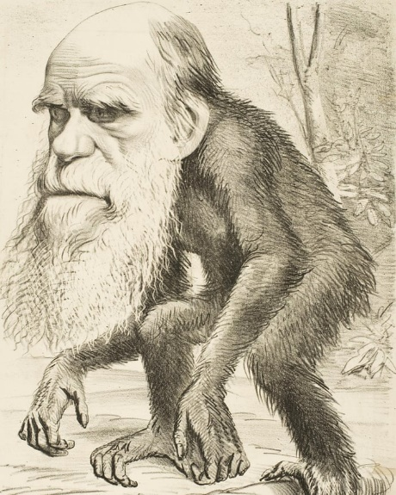
Science
Our first topic this term will be Evolution. Children will join Charles Darwin on his epic voyage aboard the Beagle to The Galapagos Islands. Children will recognise how living things have changed over time and use fossil evidence to investigate the living things which inhabited the Earth millions of years ago. Children will also recognise that living things produce offspring of the same kind, and learn how variation within species leads to adaptation.
Our second topic this term will be The Circulatory System where children will investigate first-hand the structure of the heart and the function of the circulatory system. Children will become confident scientists as they carry out experiments to investigate the impact of exercise on our bodies, whilst comparing this to the impact of other factors such as alcohol and drugs.
PE
Children will be taking part in weekly swimming lessons every Monday starting on Monday 11th September, until Monday 11th December. Swimming kit remains the same as previous years.
A weekly PE lesson will also be held each Thursday afternoon (2.00-3.00pm). PE kits, comprising of either a white or house coloured t-shirt, black shorts/leggings/jogging bottoms and sensible trainers must be present from Monday each week and will be sent home for cleaning each Friday. As PE lessons will often be outdoors, please ensure your child has warm, weather-appropriate PE kit. Absences from PE must be supported with a parental letter or phone call, detailing reasons for said absence, medical or otherwise. Any ear piercings must be removed on PE days. As staff are not permitted to help children do so, please ensure earrings are removed at home, before school on these days.

Home Learning
Home learning tasks will be set on a weekly basis – Monday to Monday. Each week, children will be given an English task and a maths task. To provide immediate feedback to your child, I will provide the answers/mark scheme directly to you via your personal account, not your child’s. Please take a weekly opportunity with your child to mark their homework with them as it provides an opportunity for you and your child to recognize and correct any misconceptions they may have had. If you are unaware of your personal E-School login details, please contact the school office as soon as possible.
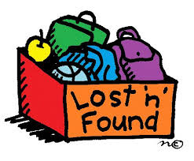
Uniform
Please ensure all items of clothing are clearly labelled as we have so many children wearing the same or similar clothing and it is easy to get muddled. Being labelled will ensure that it will find its way back to you! Please also remember that our school policy if for children to wear plain black shoes only.
Facebook
We will also be uploading regular updates to our school Facebook page. If you haven’t joined yet, just search for ‘King Street Primary School – The Home of Active Ted’. We will ensure that we have photographic permission before uploading any photos of the children.
Medication
Should your child require any medication whilst in our care, forms are available in our school office and must be completed by a parent to ensure that the medication is given correctly and safely.
As this will be your child’s final year at King Street Primary School, we will endeavour to do all we can to make it a year full of memorable experiences. Please do not hesitate to get in contact with a member of the Year 6 team via the main office or in person at the end of the school day if you have any queries or concerns.
Yours faithfully,
Mr S.Colling
Year 6 Teacher

