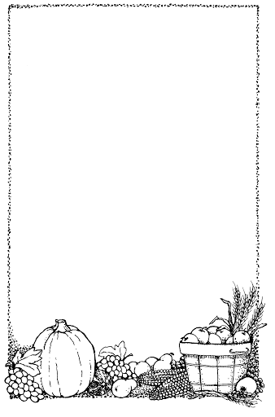
Shoes

Before I jump into my bed,

Before I dim the light,

I put my shoes together,

So they can talk all night.

I'm sure they would be lonesome,

If I tossed one here or there,

So I put my shoes together,

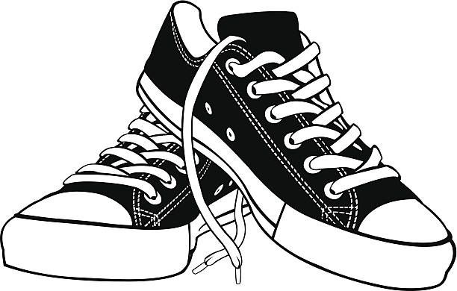
For they are a friendly pair.

The Poetry Basket www.helicopterstories.co.uk

