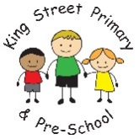

**Year 3 Autumn Newsletter**

A very big welcome to all parents and carers of children in Year 3; I hope you all had a lovely summer. We are now at the end of our first week back and the children have settled into their new class, new year group and new Key Stage well and it has been my pleasure to begin to get to know your children. We are joined this year by Miss Brown and Miss Navin who will be supporting in class across the week.

We will be studying lots of interesting and exciting topics this year, and I am looking forward to what lies ahead of us.

**Topic**

**Science**

Our Science unit this term is ‘Rocks and Soils’. We will find out how the three different types of rocks are formed, how fossils are formed, about the life and work of the palaeontologist Mary Anning, how soil is formed and the different types of soils. During our Science lessons, we will undertake a variety of activities including hands-on, practical activities, fair tests and scientific enquiries.

Our ‘Rocks and Soils’ unit also links closely with our Topic for this term.

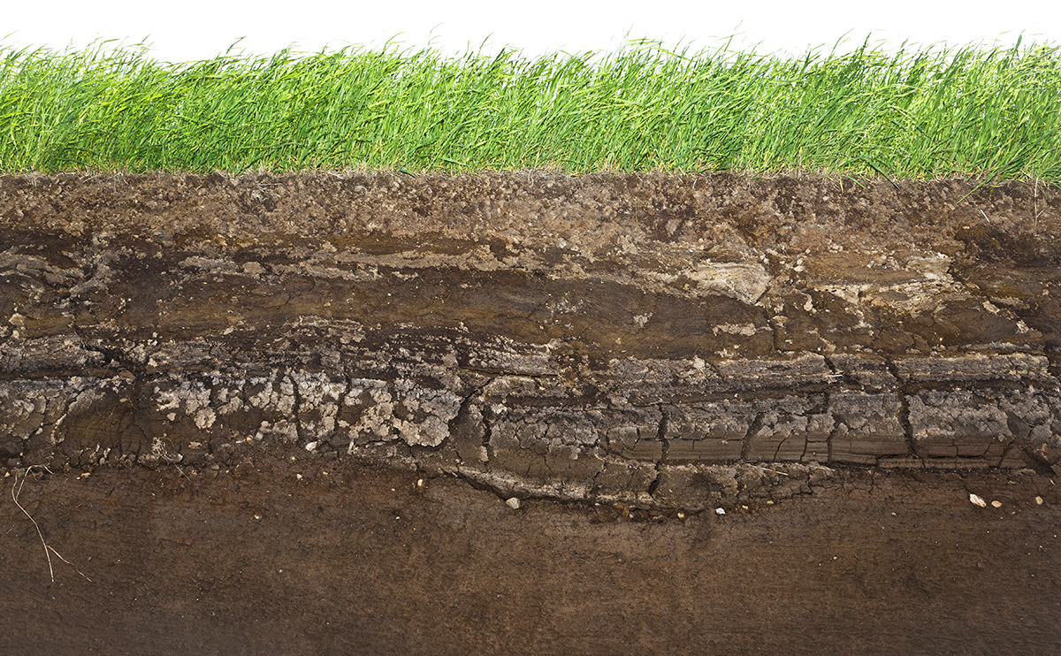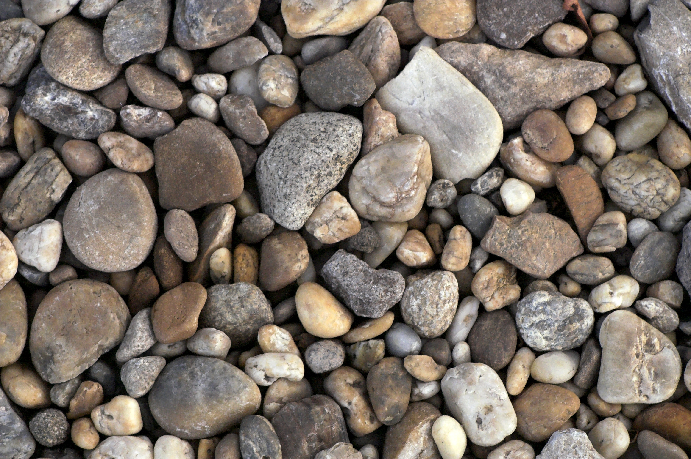

If your child’s Outdoor Ed. day is a Tuesday then their P.E. lesson will be a Thursday. If your child’s Outdoor Ed. day is a Thursday then their PE lesson will be a Tuesday. But just in case this changes, please ensure that your child brings appropriate kit to school on a Monday and takes it home for washing on a Friday.

Your child’s P.E. kit should consist of:

* plain black shorts and tracksuit bottoms.
* a plain T-shirt in your child’s House colour:
* Auckland: green
* Brancepeth: blue
* Durham: yellow
* Raby: red.
* a change of footwear.

All watches and earrings are to be removed for the session. Your support and co-operation with this is very much appreciated.



This year, every class will have 6 weeks of Outdoor Education with ‘Endless Adventure North East’.

Year 3 will participate in Outdoor Education sessions during Autumn 1.

The children have been split into 2 groups: Group A will go out every Tuesday and Group B will go out every Thursday of Autumn 1.

Every week, we will go to a different location and take part in outdoor and adventurous sporting activities linked to our science curriculum (rocks and soils) and our geography curriculum (coastal erosion, mapwork skills, compass work). Look out for the photos of our sessions on our Facebook page: ‘King Street Primary School – The Home of Active Ted’.



**Outdoor Education**

**P.E.**

Our topic for the Autumn term is ‘The Stone Age’. During our topic, we will find out when the Stone Age was, what life in the Stone Age was like and how our country changed during this time. English will be taught through texts that will help broaden your child's vocabulary, deepen their understanding, and provide a context for their own work. Some of the books that we will be reading include ‘Ug: Boy Genius of the Stone Age’, ‘How to Wash a Woolly Mammoth’, ‘The Pebble in my Pocket’ and ‘The Wild Way Home’.

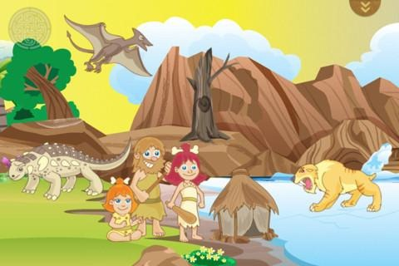



**School Dinners**

Now that your child is in Key Stage 2, if they receive a school dinner, it must be paid for. The cost of these dinners is £2.25 per day, so £11.25 for the week. However, you could be eligible for a free school meal if you meet the criteria. If you need any further information about this, please ask at the office.

Unfortunately, Key Stage 2 do not receive a snack of fruit at playtimes like Key Stage 1 do. However, your child is very welcome to bring their own fruit in from home as a snack to eat during morning playtime.

**Water bottles**

Your child is welcome to bring a bottle of still, unflavoured drinking water with them in to class. I would recommend that your child does bring a water bottle into school with them as our classroom gets very hot, especially in the afternoons, and having a bottle of water will help to cool your child down and hydrate them. Please label your child’s bottle with their name and I will ensure that bottes are taken home for washing and replenishing. If your child has a packed lunch for dinner, please ensure that they bring a drink for lunch and a water bottle for class.

**Fruit**

**Home Learning Tasks**

One final ask! Please ensure your child’s uniform, PE kit, coat, bag and other items are labelled with their name. During the year, children will inevitably take off their jumpers, cardigans and various other items of uniform then leave them in the classroom or on the yard. If they are labelled, it makes the process of finding and returning the right uniform to the right child much easier!

**Reading**

One of the most important things that you can do to support your child, is to read with

them regularly. You can listen to your child read or even share the reading with them.

From Monday, your child will start to bring home their reading book and Reading Record.

I ask that you sign their Reading Record at least three times a week, and that your child

returns their reading book to school every day so that I can listen to readers and

monitor their reading progress.

**Homework.**

This year, your child will bring home a piece of English and a piece of Maths homework

on a Monday which is to be returned by a Friday. This homework will take a variety of

forms. Some weeks, the English homework will be focussed on our spellings pattern for

that particular week, other times it will be focussed on an element of our classwork such

as grammar, punctuation or a reading comprehension. Maths will generally be linked to

our learning in class that particular week. This will be a worksheet to complete but there

might also be a supplementary online activity on Purple Mash, SumDog, Learning by

Questions or Times Table Rockstars. I will put your child’s log-in details for each of these

websites in their Home Learning books in due course and we will spend some time in class

on each website so that your child becomes familiar with each one. We will also have a

greater focus on learning our times tables this year.

And finally, just a reminder that we are holding two ‘Meet the Teacher’ sessions next Thursday; the first one from 3:15 until 3:45 p.m. and the second one from 3:45 until 4:15 p.m. where you are invited to come and meet myself, Miss Brown and Miss Navin, and find out a little bit more about life in Year 3. I look forward to meeting as many of you there as possible.

If there is anything you ever need, please don’t hesitate to catch me on the yard on a morning or a night, phone the school and leave a message or email me direct on [s.wigham100@kingstreet.durham.sch.uk](mailto:s.wigham100@kingstreet.durham.sch.uk)

Thank you once again for your support and co-operation with home-school learning.

Kind regards,

Mrs. Heightley, Miss Brown and Miss Navin.