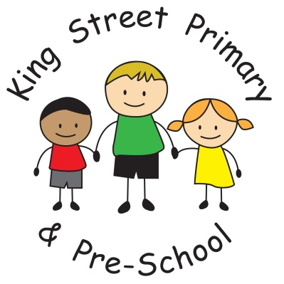

King Street Primary & Pre-School

Accessibility Policy

Policy Review Date: January 2025

Introduction
The SEN and Disability Act 2001 extended the Disability Discrimination Act 1995 (DDA) to cover education. Since September 2002, the Governing Body has had three key duties towards disabled pupils, under Part 4 of the DDA:

- not to treat disabled pupils less favourably for a reason related to their disability;
- to make reasonable adjustments for disabled pupils, so that they are not at a substantial disadvantage;
- to plan to increase access to education for disabled pupils.

This plan sets out the proposals of the Governing Body of King Street Primary & Pre-School to increase access to education for disabled pupils in the three areas required by the planning duties in the DDA:
- increasing the extent to which disabled pupils can participate in the school curriculum;
- improving the environment of the school to increase the extent to which disabled pupils can take advantage of education and associated services;
- improving the delivery to disabled pupils of information which is provided in writing for pupils who are not disabled.

Definition of Disability:
Disability is defined by the Disability Discrimination Act 1995 (DDA): ‘A person has a disability if he or she has a physical or mental impairment that has a substantial and long term adverse effect on his or her ability to carry out normal day to day activities.’

At King Street we aim to:

- eliminate discrimination, harassment, victimisation and any other conduct that is prohibited by or under this Act
- advance equality of opportunity between persons who share a relevant protected characteristic and persons who do not share it
- foster good relations between persons who share a protected characteristic and persons who do not share it

With this in mind this Accessibility Plan has been drawn up in consultation with stake holders and covers the period from January 2022 – January 2025.
We are committed to providing a fully accessible environment which values and includes all pupils, staff, parents and visitors, regardless of their age, education, physical, sensory, social, spiritual, emotional and cultural needs.
We are committed to challenging negative attitudes about disability and accessibility and to developing a culture of awareness, tolerance and inclusion.

The Accessibility Plan will contain relevant actions to:
- Improved awareness of Equality and Inclusion

- Improve access to the physical environment of the school, adding specialist facilities as necessary. This covers improvements to the physical environment of the school and physical aids to access education.

The purpose and direction of the school’s plan:
At King Street we are committed to giving all of our children every opportunity to achieve the highest of standards. We do this by taking account of pupils’ varied life experiences and needs.

We offer a broad and balanced curriculum and have high expectations for all children. The achievements, attitudes and well-being of all our children matter.
We aim to increase access to the curriculum for pupils with a disability, expanding the curriculum as necessary to ensure that pupils with a disability are as, equally, prepared for life as are the able-bodied pupils; (If a school fails to do this they are in breach of the Equality Act 2010).

This covers teaching and learning and the wider curriculum of the school such as participation in after-school clubs, leisure and cultural activities or school visits. It also covers the provision of specialist aids and equipment which may assist these pupils in accessing the curriculum.

King Street promotes the individuality of all our children, irrespective of ethnicity, attainment, age, disability, gender or background.

Our school aims to be an inclusive school. We actively seek to remove the barriers to learning and participation that can hinder or exclude individual pupils, or groups of pupils. This means that equality of opportunity must be a reality for our children:
- girls and boys
- minority ethnic and faith groups
- children who need support to learn English as an additional language
- children with special educational needs
- gifted and talented children
- children who are vulnerable

We acknowledge that there may be times when this is impossible or inappropriate, despite our wishes or best efforts.
We aim to improve the delivery of written information to pupils, staff, parents and visitors with disabilities, examples might include: handouts, timetables, textbooks and information about the school and school events. The information should be made available in various preferred formats within a reasonable time frame.

Please see the Action Plan which relates to these key aspects of accessibility.
This plan will be reviewed and adjusted on an annual basis, a new plan will be drawn up every three years.
We acknowledge that there is a need for ongoing raising of awareness and training for staff and governors in the matter of disability discrimination and the need to inform attitudes on this matter.
The Action Plan for physical accessibility relates to the Access Audit of the School, which is undertaken regularly by the Local Authority.
It may not be feasible to undertake some of the works during the life of this first Accessibility Plan and therefore some items will roll forward into subsequent plans.

January 2022
Review January 2025

