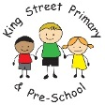
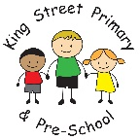
Year 4 Spring Term Newsletter

Welcome back, and a happy new year to you all! We hope you’ve all enjoyed some quality family time over the Christmas holidays, and are feeling refreshed and ready for 2024. The children have come back ready to learn, and are already showing focus and determination in these first few days, and I’m sure that this positive attitude will allow them all to enjoy a busy Spring term!
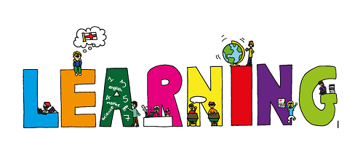
Maths
Our focus this term will be on multiplication and division, including introduced formal, efficient written methods. This will then provide a strong foundation for the children to move on to fractions and decimals later in the Spring term. This area of learning is absolutely key in your child’s development as a mathematician, and knowing their times tables up to 12x12 fluently (especially out of order) is of the utmost importance. Please encourage your child to be practising these regularly (there are also lots of games and activities on EdShed, and there will be a times tables of the week as part of homework too). Further information is attached about the Multiplication Check which will be taking place in the Summer term.

English
Much of our reading and writing this term will be based around our learning about ‘The Vikings’ in History, and about Climate Change in Geography. These are both fascinating and challenging topics, and will provide opportunities for your child to create work across a range of genres, including kennings in poetry, instructions and explanations, and as a chance to develop their acting and directing skills in writing and performing their own playscripts. We will continue to work hard on developing our joined handwriting and improving our vocabulary too, as well as continuing to enjoy reading for pleasure together with several new texts: ‘The Land of Roar’ by Jenny McLachlan, ‘Firebird’ by Saviour Pirotta, ‘Alice’s Adventures in Wonderland’ by Lewis Carroll, ‘The Ice Bear’ by Jackie Morris and ‘Here We Are’ by Oliver Jeffers. Year 4 love reading and we take great care to explore a range of genres and interests in our selection of texts – I’m sure you’ll be hearing about their favourites over the coming weeks!

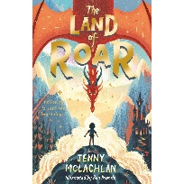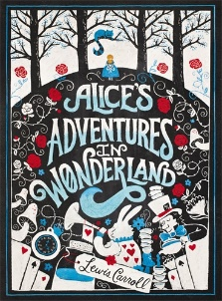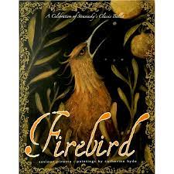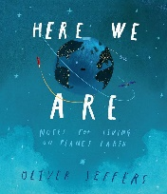

Reading
Reading records need to be completed at least three times weekly, and reading books and reading records need to be brought into school every day as reading is a vital part of our school day. Please take the time to read with your child as often as possible, and focus on their understanding on the text by asking questions (see the middle pages inside their reading record for some useful hints and tips). By Year 4, most children can confidently read aloud, and decipher new vocabulary, so the key to progress is their comprehension (understanding). To encourage greater independence in Year 4, children are encouraged to review their own reading too by rating themselves out of 10 in their reading record!
Science
Our new topic this term is ‘Sound’ and the children have already shown their enthusiasm in a recreation of different sounds using objects around class (the jackhammer was particularly loud!) There will be lots of opportunities to investigate, experiment, observe and predict as part of our learning, and help us to build on previous learning. We will then be going on to learn about ‘Electricity’.

Foundation Subjects
Here is a brief overview of our intended learning across all curriculum subjects this term – we know all children have different interests and talents, and there’s something here for everybody!

Art | Textiles & Drawing: the Bayeux Tapesty
Computing | Data Logging  Photo Editing
Design Technology | Food; Healthy & Varied diet (baking bread)
French | Family members  Using nouns and adjectives in French
Geography | Biomes, climate zones and vegetation belts around the world (exploring climate and weather patterns)
History | The Vikings  Britain to 1066 – invaders, settlers and conquests
Music | Edvard Grieg – ‘In the Hall of the Mountain King’  Classical music, composing and performing
PE | Handball  Cricket  Basketball  Outdoor Education
PSHE | Physical Health & Mental Wellbeing  Growing & Changing  Respecting Ourselves & Others
RE | Judaism: celebrations, beliefs and practices for modern-day Jewish people, at home and in the synagogue

PE
Our PE lessons will take place on Mondays and Fridays, though we may change the days to take advantage of the (hopefully) improving Spring weather. PE kit should consist of: tracksuit bottoms/leggings, trainers and a change of top (preferably a school t-shirt in house colours), as well as a sweatshirt for the outdoors. Please send PE kits in to school with your child on a Monday, and these will be sent home on Fridays, to ensure that they are available every day. We will also be starting Outdoor Education in February – look out for more details coming soon. I know how much the children will enjoy this opportunity again.

Home Learning
Homework will be set online on ‘EdShed’, which the children are now all confident in using. This will be set on a Monday to be completed by Friday. Other homework tasks and projects may be set over the term linked to our current areas of learning.

Thank you once again for your continued support. If you have any questions, please do not hesitate to come and speak to us, or make an appointment.

Miss Bell, Mrs Scott & Miss Navin

