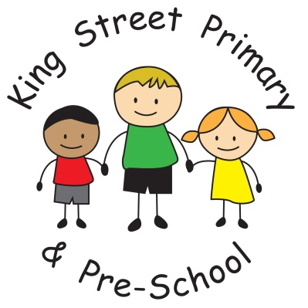

King Street Primary & Pre-School

Uniform Policy

Policy Review Date: April 2023

Introduction
At King Street we expect our children to wear school uniform. A uniform reinforces in children a pride in their appearance, instils recognition of themselves as an integral part of the school community and assists in developing pride in representing their school.
Issues of equality, health and safety and expense are also factors that contribute to the establishment of this policy.

Aims and Objectives
The school believes the following are the benefits derived from the wearing of school uniform by all children.

- Promotes a sense of identity and pride in our school
- Promotes equality amongst all children
- Is practical and smart
- Reduces competition amongst children to wear fashionable items for daily wear
- School uniform is functional, durable and economical
- Helps identification and safety of children in public places

King Street school uniform must consist of a blue sweatshirt or cardigan, white polo shirt, black or grey trousers/ skirt/shorts and smart, plain black footwear without a high heel.
Uniform is not specific to gender and families/children can choose either skirts/dresses or trousers. We always seek ways to ensure that the cost of a school uniform is not restrictive to parents and therefore it is not a requirement for children to wear clothing branded with the school logo. Unbranded uniforms are very popular and can be purchased from most supermarkets. We also hold termly uniform events where high quality, second hand uniforms can be collected free of charge. If families do require support obtaining correct school uniform, support is available through school and families should contact the school office. Where families wish to purchase branded uniform items, uniform is available to purchase on our school website (via the shop link) or by calling into Cre8ive Graphics (Peel Street, Bishop Auckland) throughout the year. Please ensure all uniform is named.

Physical Education
It is essential that children change for PE. Children in Key Stage 1 can use either plimsols or trainers. Key Stage 2 children will need trainers for physical activity. These do not need to be new trainers. Children are encouraged to wear a plain t shirt in the colour of their ‘ school house team’ but these do not need to have the school logo on and can be purchased from local supermarkets. Children are allocated ‘house teams’ when they start school and siblings follow in the same team so clothing can be reused. Children can wear leggings, jogging bottoms or shorts for PE but may want to consider the weather as PE sessions are often held outdoors throughout the year.

Jewellery
Stud earrings can be worn during the school day but must be removed for physical activity such as PE or outdoor education. This is in the interests of your child’s safety.
Parents should note that if they intend to have a child’s ears pierced this needs to be carried out at the beginning of the summer holidays to allow time for ears to heal. Stud earrings should be very small and not cause a risk of being caught in clothing or hair.

Extreme Haircuts
The school does not permit children to have haircuts that could serve as a distraction to other children, or heavily styled hair using excessive product which may vary depending on current fashionable styles.
The role of parents
We ask all parents who send their children to our school to support the school uniform policy. We believe that parents have a duty to send their children to school correctly dressed and ready for their daily schoolwork. Parents should ensure that their child has the correct uniform, and that it is clean and in good condition. We always seek to support families financially with the costs of uniforms if required and requests for support can be made by email to the school office. All requests are confidential.

The school welcomes children from all backgrounds and faith communities. If there are serious reasons, e.g. religious objections, why parents want their child to wear clothes that differ from the school uniform, the school will look sympathetically at such requests. Similarly, should an item of school uniform prove problematic for a pupil with disabilities, then parents are invited to draw this to the attention of the Head teacher. The school will not treat pupils with disabilities unfavourably.

The role of governors
The governing body supports the Head teacher in implementing the school uniform policy. It considers all representations from parents regarding this policy, and liaises with the Head teacher to ensure that the policy is implemented fairly and with sensitivity.
It is the governors' responsibility to ensure that the school uniform meets all national regulations concerning equal opportunities, and that our school uniform policy is consistent with our policy on equal opportunities.
Governors ensure that the school uniform policy helps children to dress sensibly, in clothing that is hardwearing, safe and practical.
Monitoring and review
When monitoring this policy, through its committee work, the governing body will:
- seek the views of parents, to be sure that they agree with the policy, and support it;
- consider with the Head teacher any requests from parents for individual children to have special dispensations;
- require the Head teacher to report to the governors on the way in which the policy is being implemented.

