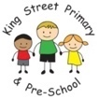
Reception Class September 2023
EYFS Autumn Term Newsletter
Welcome to all our families old and new! We have been so excited to welcome you and your fantastic little ones into our school community.
We are incredibly proud of our EYFS provision at King Street and we are thrilled to finally be able to share our calm and cosy learning landscape with our new starters this week. Our internal roofing and electrical rewiring work was completed last week and staff have worked incredibly hard to move all of our equipment back and make our learning environment even better! We are hoping that our outdoor space will be finished very soon too!
All of our new starters are settling well, learning the new routines, making new friends and have been very busy learning in our Reception classroom.
In the past few days our staff have been spending time with the children, getting to know them and introducing them to all of the new areas to explore. We have already been building amazing structures in our block area, Looking after the babies in the home corner, reading in our cosy reading nook, exploring outdoors and adding our handprints to our ever-growing EYFS Family display to name just a few things!
The first few weeks of this term will be spent getting to know your VIP's a little better. Our focus will be on building the children’s confidence, independence, self-esteem and the social side of children’s learning as we introduce them to new experiences. Learning what interests them, what they know and what they want to know will help us to continually tailor our provision to help them to enjoy their time in EYFS and achieve their full potential.
Our broad and ambitious Reception curriculum – Last year we asked all parents, school staff and governors what they felt were important goals for our children to achieve. We used this information to create a broad and ambitious curriculum which prepares our children for the next steps of their learning journey throughout King Street Primary. I have attached a copy of our curriculum to this newsletter.
We will be exploring sounds, textures, language, feelings, mark-making, movement, pattern, shapes and numbers through our play and focused learning time. Our overarching themes this term are: ‘This Is Me’, ‘In The Town Where I Was Born’ and ‘Celebrations’.
Our key texts this half term are: The Little Red Hen, Elmer and The Bog Baby and after half-term we will be Aaaargh Spider!, We’re Going on a Bear Hunt and Jesus’ Christmas Party
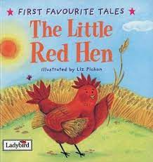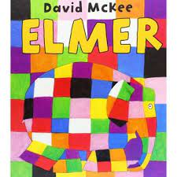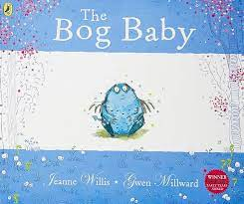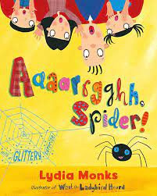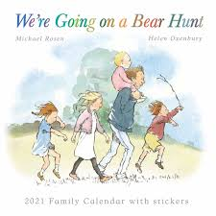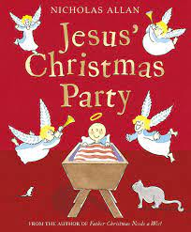

Uniform - Our children are expected to wear a blue school jumper or cardigan, grey/black bottoms white polo shirt and black school shoes. We suggest that our younger children wear elasticated bottoms of some sort to enable their independence when visiting the toilet. It would be helpful to provide spare items of clothing (which don’t have to be uniform) in a clearly labelled bag, which can be brought into school on a Monday and left on their child’s peg all week in case of little accidents. Please let us know if your children have any issues in this area and we will support in any way that we can.
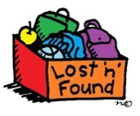
Please ensure all items of clothing (including shoes and wellies) are clearly labelled with your child’s name or initials as we have so many children wearing the same or similar clothing it is easy to get muddled. Being labelled will ensure that it will find its way back to you. We have over 50 children across our setting all wearing similar sizes, so it can often be a challenge!
We will do our best to protect your children's clothing when they are painting etc. but expect them to get dirty from time to time as they are learning through exploring!
P.E. – Our active ‘Movement Monday’ sessions take place on Mondays. Children can come ready in jogging bottoms or leggings, so they just need to change from a jumper and polo shirt to their t-shirt.
Welly Wednesday - We are incredibly lucky to be able to offer a Forest School session once a week, whatever the weather! Please ensure that children come to school ready in their outdoor clothing and bring waterproofs and wellies with them. Wellies can be left all week for outdoor play if you prefer. We do have a limited supply of waterproofs and wellies if you don’t have your own.
Children becoming readers/Bookworms - By the end of next week all, of our children will have brought home a reading record and a book of their choice to share at home. At King Street, we value reading and believe that sharing stories together will spark a lifelong love of reading. Reading is the key to unlock children’s potential so learning to read is vital for future success. As the term goes on, Reception children will receive a book linked to phonics ability. Books are changed on a Monday and we listen to children read every day, so it is important that books bags and reading records are brought in every morning. Re-reading books is important for developing fluency Further information on reading will be sent in your child’s book bag and talked about at our ‘Introduction to Phonics’ meeting which takes place next Monday, which will help explain how best to support your child in their early reading journey! Last year’s parents found the meeting run by Mrs Kane and Miss Whitfield incredibly useful. We really hope that you are able to attend as a shared approach to reading accelerates progress.
Tapestry - Forming a good partnership between home and school is really important to us. We will be continually adding information and evidence on your child's development to their learning journals via the Tapestry app, so please let us know of any proud moments that you have at home with your child, as this helps us to gain a better picture of your child both at home and school and how best to support their learning and development. If you haven’t yet completed the consent forms to join Tapestry, please let us know and we can send an invitation via email which will let you see your child’s progress throughout their time with us. More than one parent/carer/family member can be added. Please ensure that you check your email junk folder for the invite if you have not yet received it. No one else, other than EYFS staff can see you child‘s account as it is only visible by account holders. I would like to remind you that sharing of information or media from your child’s journal on social media is not permitted to ensure the safeguarding of all our children. We would also be grateful if you ‘liked’ or commented on each post, so that we can see that you are getting all the information sent. Home-learning tasks and information will be sent weekly via the memo feature.
Medication - Should your child require any medication whilst in our care, forms are available in our school office and must be completed by a parent to ensure that the medication is given correctly and safely. If your child is unwell, they should not attend school. If you are unsure, please contact our school office, who will be happy to help. Children who have sickness or diarrhoea must not return to school until 48 hours after the last episode.
Please ensure that the school office is kept up to date with changed to your information such as a new address or phone number. This is to ensure that we can contact you in case of an emergency.
Collecting children – At the end of the day, staff will come to the double glass doors and call for children to come to meet their parent/carer. Please be patient with staff as we have a duty of care to ensure that every child is collected safely, and it can often be very busy. We ask that you stay back from the glass doors so that children can see their parents easily. We understand that there are times when another person needs to collect your child. We would be grateful if you could call the office to let them know so that they can pass the message on to EYFS staff. This ensures that there is no delay to your child being released from the care of our staff.
Finally, please remember that we are here for you, and we want to help in any way we can. If you do have any concerns or if something is having an impact upon you or your child, please contact your child's Key Person. Urgent messages can be left with staff on the door on a morning - however, we would prefer it if you could email staff, message them through Tapestry or phone school directly as this helps us to get all of our children into school quickly and safely. Your child’s Key Person will then get back to you as soon as possible. Anything you tell us will be dealt with in the strictest confidence.
The early years of education are important as they lay the foundations for a lifetime of learning, so we want the experiences of EYFS to be positive. We really hope that your children are enjoying their time at King Street as much as we are enjoying welcoming those smiling faces every day!
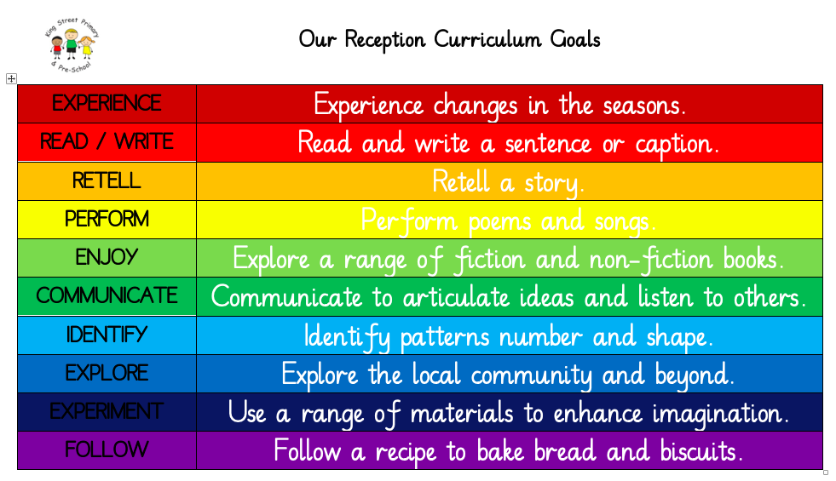

The EYFS Reception Team – Miss Whitfield and Miss Starkie

