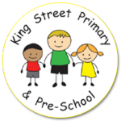
Year 5 Spring Term Newsletter
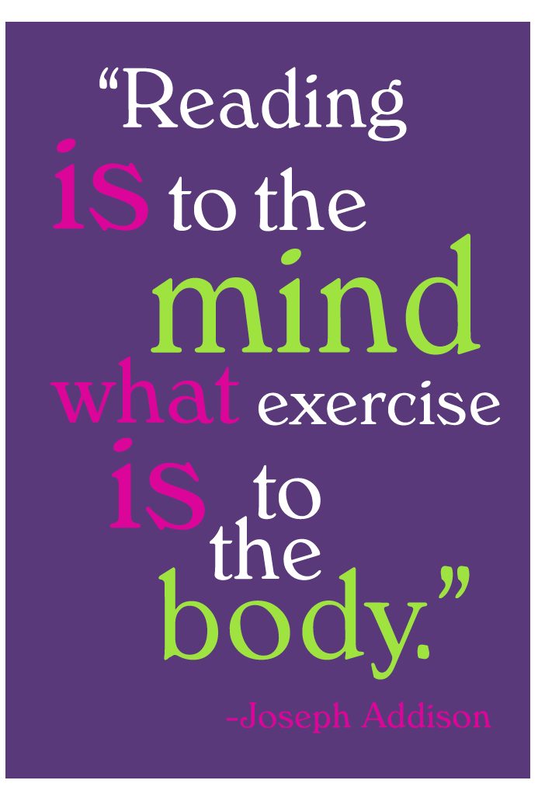
Miss Lloyd, Mrs Bott and Miss Navin would like the opportunity to welcome everyone back after the holidays! We hope you all had a restful Christmas and are ready for what this term has in store for the children.
Reading
- Reading is monitored daily and children should have their school reading book and record in school every day so we can listen to children read 1:1.
- The expectation is that children read three times a week at home. They are welcome to fill in their own reading record but they are still required to have a parent signature.
- Reading books go home each night and are collected on a Friday for changing. Children do have the opportunity to take their books home over the weekend to read too.
- We try to avoid changing books mid-week as this ensures the children have time to read and fully understand the texts. Despite not being very long, the topics are often much more sophisticated, and children require time to discuss and fully understand the theme of their book.
- Please take the time to read with your child and focus on their understanding of the text by asking questions.
- Each child has a reading loyalty card. If they read three times a week, they receive a stamp on their loyalty card. When they fill in one row, they receive a small treat/reward.
PE
This term our PE lessons will take place on a Monday and Wednesday. For netball, pupils will need tracksuit bottoms, a sweatshirt, a plain t-shirt in their house colour and, trainers. Long hair should be tied back and earrings taken out or covered for PE. PE kits should be sent with your child on a Monday and we will send them home on a Friday.
Swimming lessons start on Monday 15th January 2024. Please ensure you send the appropriate swimming kit with your child every Monday. Your child requires a swimming costume/swimming trunks that fit, swimming hat, towel and goggles (if wanted).

Homework
- Homework is set on Monday on the Spelling Shed website (https://www.spellingshed.com/en-gb/). Tasks run until Sunday evening at 8:00pm.
- Children are familiar with this platform and use it within school. Login information was stuck into their reading records last term.
- Children who would like paper copies of homework just need to ask on a Monday, when homework is set!

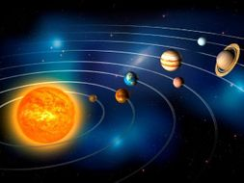
Our topic this term is ‘Out of this World. As you will have guessed, we will be exploring and learning all about space and forces during this term. We have some very keen space enthusiasts in our class, who I know are very excited about this topic!
Some of our reading and writing lessons will also be inspired by space. We will be reading the Frank Cottrell-Boyce story ‘Cosmic – it’s One Giant Leap for Boy-Kind’. It’s all about a boy who accidentally ends up in space!
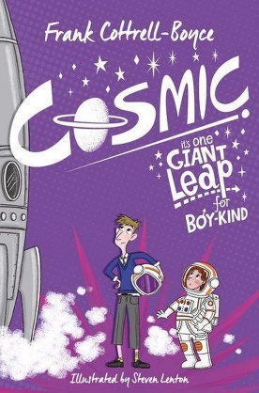
In History, we will learn about the Greek states of Athens and Sparta, warfare, culture, beliefs and the legacy left behind by the Ancient Greeks. In Geography, we will be investigating the significance of latitude, longitude, Equator, Northern Hemisphere, Southern Hemisphere, the Tropics of Cancer and Capricorn, Arctic and Antarctic Circle, and time zones. As well as learning about how mountains are formed, volcanoes and earthquakes. This will link nicely with our science work about the Earth.
In Maths, we will be focusing on fractions and multiplication and division. Please ensure your child knows and regularly practises their times tables. This can be the reason many children find these concepts tricky! Times tables games are available on the Spelling Shed homework platform!
In art this term, we will be exploring the work of artist Peter Thorpe. He is well known for his abstract space paintings. We will be using his work as inspiration and will be using mixed media to create our artwork.
Thank you again for your continued support. If you need to get in contact with us, please do not hesitate to email, call the school office or see me directly and I will try my best to help!

Miss Lloyd

