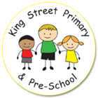
King Street EYFS Unit
Nursery
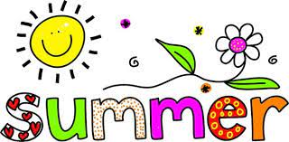
Term Newsletter 2022
Welcome to the beginning of our Summer Term. We can’t quite believe we are now entering the final term of our year. The year just seems to have flown by.
All of the children seem to have grown again over Easter! Just a reminder that all items of children’s clothing should be clearly labelled so that we can return any missing things more easily. As our nursery is almost full, we now have over 50 children sharing the same learning space wearing the same colours and similar sizes, so you can imagine what a difficult task it can be to sort lost property at the end of the day without names inside! Our children access a large space, both inside and out as well as the lunch hall and often they do not remember where they have left their belongings. Sometimes jumpers and cardigans do get muddled, so please check when washing and return to school if your child has picked up the wrong one!
We are hoping that the sunny weather will feature a lot this term, but we want to ensure that children are safe in the sun. We ask that when sun is forecast, sun cream is applied before children come to school and then a clearly name-labelled bottle of sun cream is left in school so that staff can assist children to reapply throughout the school day. We already have sun hats in school for children to protect themselves from the sun. Children should also bring a water bottle with fresh water into school each morning for accessing throughout the day.
This half-term our theme is and Good to Grow where children continue to learn about the growth of plants and animals before moving onto Ticket to Ride, where children will explore vehicles and moving around.
Transition
As we get some of the children prepared for their transition to Reception we will be doing some more focused phase 1 phonics activities with our N2 children as well as some more group time focused on numbers. We will be looking at rhyming a lot with all of the nursery children and would love it if we could find out some favourite family rhymes.
Reading
Please continue to send in your child’s reading book regularly, we do have some children who have not returned their books for a while, please don’t worry if you have lost a reading book just let us know and we can send new ones.
Writing
We encourage children to write their names or first initial on any work pictures they produce and would be grateful if you could continue to encourage this at home.
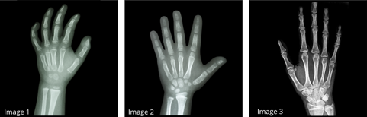
Children need lots of chances to play with dough and block building as this will strengthen their hands ready for writing. Why not try sticking paper onto a vertical surface for mark-making or on the underside of a table for fun. Further information on physical development can be found here: https://www.momtessoriway.com/post/understanding-our-bodies
Fresh Air Friday
A reminder that our Fresh Air Friday continues this term, no matter what the weather. Please ensure that your child is dressed appropriately for the weather. We do have some waterproof trousers available and sun hats, wellies and gloves in an emergency.
We update our website Gallery each week with photographs and a description of our sessions and often add photographs to our closed Facebook page King Street Primary School – The Home of Active Ted.

And finally, thank you all so much for your continued support. Remember we are here to support you and your family where we can. If you have any questions or concerns, you can speak to us directly, email us or leave a message with the school office and we will contact you as soon as possible.

Miss Brown, Mrs McGonigal and Mrs Angus

